Data quality checks for the update of the EEA

EU ETS data viewer

Latest Dataset October 2026

Authors:
Christian Nissen (Öko-Institut)


Contents

Contents 1
List of Tables 2
1. Data quality checks for the update of the EEA EU ETS data viewer 3
Key Findings 3
2. Consistency checks 5
Deletion of double installations 5
Reallocation of main activity codes 5
3. Main changes in EU ETS viewer data between April 2025 and May 2025 8
Number of entities included in the scheme 8
Verified emissions (stationary installations) 9
Free allocation to existing installations from 2005 to 2024 (stationary installations) 10
Surrendered units from 2005 to 2024 (stationary installations) 11
Aviation 11

List of Tables

Table 1.1 Comparison of the 2025/2026 data sets 4
Table 2.1 Number of installations with old activity type codes 5
Table 2.2 Allocation of new activity codes to installation with old codes 7
Table 3.1 Number of entities by country 8
Table 3.2 Changes in VE between datasets (stationary installations) 10
Table 3.3 Changes in free allocations between datasets (stationary installations) 11
Table 3.4 Changes in VE, free allocation and surrendered units to aviation operators 12
Table 3.2 Changes in VE between datasets (stationary installations) 14
Table 4.1 Verified emissions (Mt CO2 equivalent) by Member State, sector, and year 16

Data quality checks for the update of the EEA EU ETS data viewer
The EU ETS data viewer offers easy access to emission trading data from the European Commission’s Union Registry website (previously European Union Transaction Log, EUTL). The Union Registry is the Commission’s online database that helps to ensure accurate accounting of allowances issued under the EU ETS. The EU ETS data viewer provides aggregated data by country, by main activity type and by year on the verified emissions, allowances and surrendered units. The data reported under the EU emission trading system covers more than 16000 stationary installations, 1600 aircraft operators and 2600 maritime operators.

The EEA EU ETS data viewer is updated multiple times per year. Before the latest EU ETS data are uploaded, the ETC-CM conducts quality checks to better understand changes between dataset versions. This paper outlines the results of the data quality checks and updates made in the EU ETS data viewer. The checks focus primarily on data consistency, particularly the deletion of double installations and the reallocation of main activity codes. From 2026 onwards, a gap-filling procedure is applied to account for the effects of installations that have not yet submitted their emissions reports at the time of data extraction, providing a more complete picture of total emissions even in early dataset versions.

The current dataset was downloaded on 12 October 2026. The comparison dataset is from 4 September 2026. It should be noted that, at the time of data extraction, the compliance cycle for the reporting year is not yet completed. If more significant changes are identified in the future, additional updates of the data viewer may be carried out.

Timeline of the process

The annual update process starts with the first release in April. These data provide an early indication of submitted emissions reports, but experience shows that not all operators report on time. Further updates are scheduled for July and September. From 2025 onwards, an additional update will be released after the conclusion of the compliance cycle in October. This change reflects the fact that, unlike in previous years, compliance is no longer completed by July. As a result, the completeness of the July dataset can no longer be assumed, and the September or post-compliance October dataset will be used as the basis for related EEA and ETC products, such as the annual EU ETS report.

Key Findings
Table 1.1 Comparison of the 2026 data sets
DataExtract | 9 April 2026 | 1 July 2026 | 3 Sept 2026 | 12 Oct 2026
DataRows | 22 412 | 22 627 | 22 746 | 22 868
Stationary | 16 715 | 16 774 | 16 763 | 16 773
Aircraft operators | 1 704 | 1 712 | 1 716 | 1 727
Maritime operators | 3 993 | 4 141 | 4 267 | 4 368
Verified Emissions (2025) [Mt] | 1 077 | 1 148 | 1154 | 1 162
Stationary [Mt] | 963 | 1 009 | 1011 | 1 013
Aircraft operators [Mt] | 57 | 58 | 59 | 62
Maritime operators [Mt] | 57 | 81 | 84 | 88
Allocated (2025) [M] | 492 | 491 | 492 | 494
Stationary [M] | 482 | 481 | 481 | 483
Aircraft operators [M] | 11 | 11 | 11 | 11
Maritime operators [M] | - | - | - | -
Surrendered Units (2025) [M] | 94 | 322 | 494 | 1 128
Stationary [M] | 92 | 301 | 444 | 1 006
Aircraft operators [M] | 1 | 13 | 26 | 61
Maritime operators [M] | 2 | 7 | 23 | 61
Sources: Union Registry extract 9 April 2026, Union Registry extract 1 July 2026, Union Registry extract 4 September 2026, Union Registry extract 12 October 2026

Consistency checks
As part of the previous update, a series of consistency checks were carried out, including a comparison with the preceding dataset to identify any significant changes between versions.

For the current update, the dataset downloaded on 12 October 2026 was compared to the 4 September 2026 dataset to track changes and assess the current state of data completeness.

In previous years, the analysis was based on a dataset provided directly by the European Commission (COM). However, this information can now be accessed directly from the Union Registry. Therefore, the current analyses are based on the files available under the "Data Download" section: "Operators Daily" and "Operators Yearly Activity Daily."

Regarding ETS2: In the September 2025 dataset, a new activity code had been introduced, Activity Code 60 "ETS2 MS Account", representing member state accounts under the ETS2 framework, with approximately 974 Mt of CO2 reported as preliminary unverified emissions. However, these entries have since been removed from the Union Registry. The current September 2026 dataset therefore contains no ETS2 data, and Activity Code 60 is no longer present.

Reallocation of main activity codes
Before 2012, in the 1st and 2nd trading period, the EUTL contained information for nine categories of activities for stationary installations. With the start of the 3rd trading period (2013-2020), new activity categories have been introduced resulting in 28 categories for stationary installations to date, some of which correspond to previous categories, while others changed to new ones.

In total, 3,448 installations (approximately 21% of all installations) still report old activity codes (see Table 2.1). This is one more than in the July 2026 dataset. The installation CZ108 was reattributed from Activity Code 36 back to 1. It is unclear why this was done.
Table 2.1 Number of installations with old activity type codes
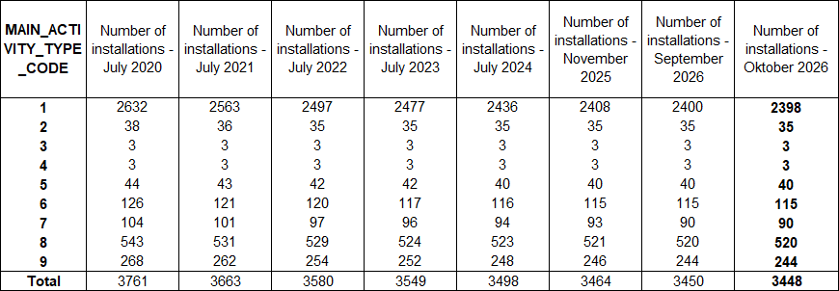
Sources: Union Registry extract 12 October 2026 and former extracts, own calculation

Since 2015 the EU ETS data viewer no longer includes old activity codes except for code 99, which will remain if no other country specific information is available. For the installations reporting an old code, a correction is made. Since 2015 the translation procedure follows the methodology explained in the ETC/ACM document "Attribution of new activity codes for installations with old codes in the EEA's EU ETS data viewer" (latest version as of April 2016). The result of this methodology has been amended with country specific information. The translation table is publicly available to make the translation of activity codes as transparent as possible.
As highlighted in the methodology document, there is a risk that the number of installations allocated to activity codes 38 to 41 (Production of specific chemicals) is underestimated, because the allocation to these codes is not possible without further detailed knowledge of the activity of single installations.
Consequently, there is also a risk that the number of installations allocated to activity code 42 (Production of bulk chemicals) is overestimated.
Looking at verified emissions 2025 (see Table 2.2), the difference in emissions for installations with code 42 due to the translation process has been reduced to approximately 0.01 Mt, with emissions increasing marginally from 29.6 Mt before to 29.6 Mt after translation, affecting 94 installations.
Similarly, it is not possible to differentiate between the production of primary (code 26) and secondary aluminium (code 27) without more information on single installations. NACE code 24.42 (Aluminium
production) has been completely translated to code 26, leading to a possible overestimation in code 26 and an underestimation in code 27.
For the September 2026 dataset, 7 installations were translated to code 26, consistent with the previous update.
The installations FR 956, SK 150 and CZ 73 were relocated from code 20 to code 24 based on information from the Member States, as these plants are foremost steel plants.
For further details see Table 2.2.

Table 2.2 Allocation of new activity codes to installation with old codes
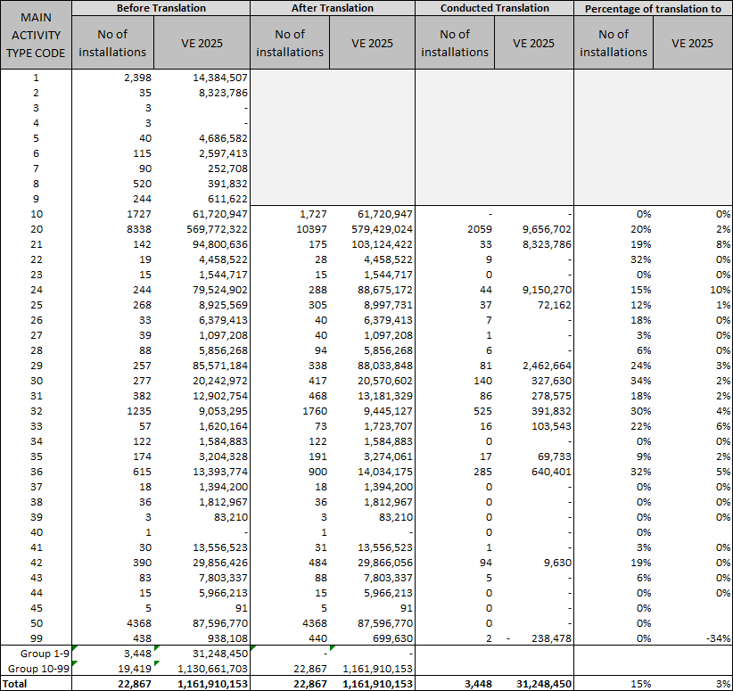
Note: The total number of translations given in the table (3 4508 is not the absolute number of translations, because a small amount of other translations took place in the activity type codes 20-99.
Sources: Union Registry extract 12 October 2026

Main changes in EU ETS viewer data between September 2026 and October 2026

Number of entities included in the scheme
The number of stationary installations, aviation and maritime operators by country is shown in the following table:

Table 3.1 Number of entities by country
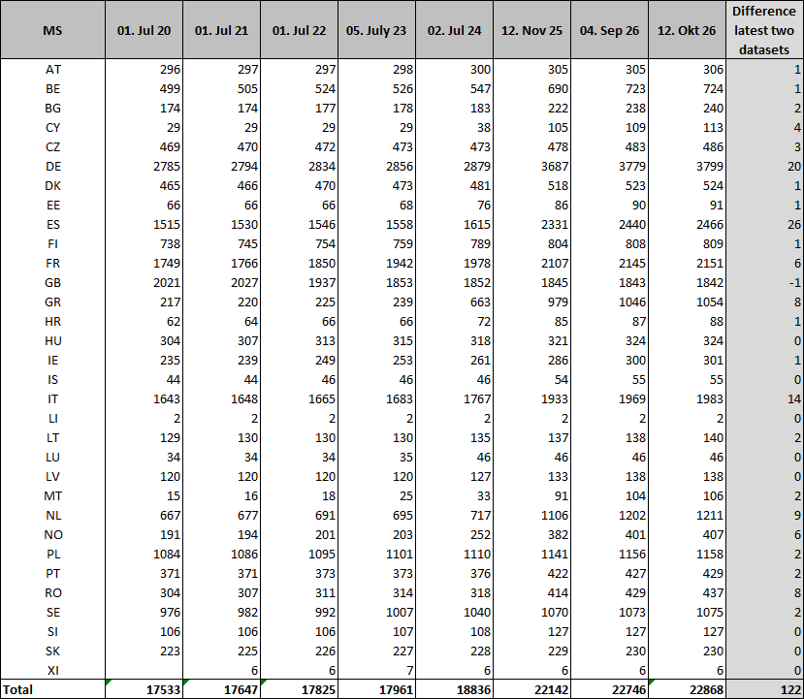
Sources: Union Registry extract 12 October 2026 and former extracts, own calculation

As shown in Table 3.1, the October 2026 dataset includes 122 more entities than the September 2026 dataset.

In 2025, the EU ETS registry recorded 584 new entrants and 598 closures, resulting in a net reduction of 14 installations. The majority of new entrants are listed under activity code 50, reflecting the inclusion of maritime operators following the extension of the EU ETS to the maritime sector. The remaining new entrants are distributed across other activity codes.
The closure figures are dominated by Sweden (484 closures). This reflects small district heating installations that Sweden had previously opted into ETS1 despite being below the 20 MW threshold, and which have now been closed in the registry as they will be covered under ETS2 from 2027 onwards. Excluding Sweden, total closures amount to 81, in line with previous years.
Table 3.2 EU ETS registry changes 2025 by member state
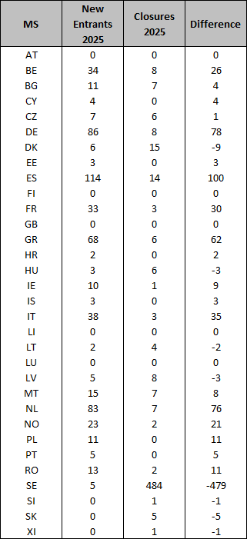
Sources: Union Registry extract 4 Septmber 2026 and former extracts, own calculation

Verified emissions (stationary installations)
In the following table, data on verified emission is compared between the datasets from September 2026 and October 2026, just for stationary data. Differences are shown as percentages, calculated from the difference related to latest data.
Table 3.2 Changes in VE between datasets (stationary installations)
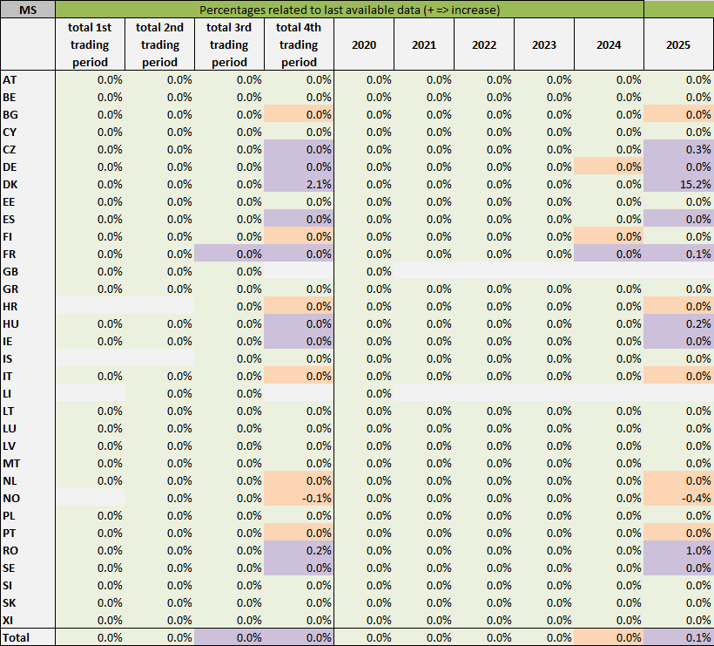
Note: Calculated as difference between July and September 2026 data
Purple: increase, light orange: decrease, green: zero difference.
Due to rounding to one decimal place, some values displayed as 0.0% may still contain very small underlying changes. Cell colours reflect the direction of these unrounded changes.
Sources: Union Registry extract 12 October 2026 and former extracts, own calculation
In general, there are no changes for the first and second trading period and minor changes for the third trading period.

Free allocation to existing installations from 2005 to 2026 (stationary installations)
In the same structure, the data on free allowances to existing installations allocated under Article 10a(1) has been compared:

Table 3.3 Changes in free allocations between datasets (stationary installations)
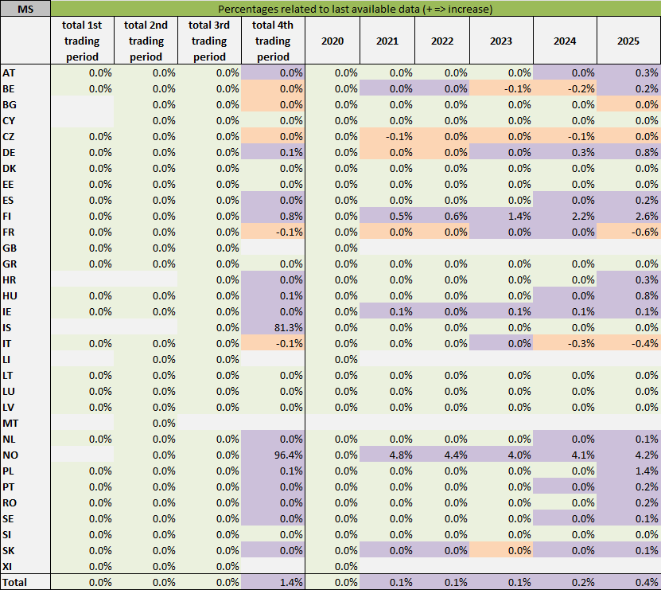
Note: Calculated as difference between July and September 2026 data
Purple: increase, light orange: decrease, green: zero difference.
Due to rounding to one decimal place, some values displayed as 0.0% may still contain very small underlying changes. Cell colours reflect the direction of these unrounded changes.
Sources: Union Registry extract 12 October 2026 and former extracts, own calculation
In general, there are no changes for the first and minor changes in the second and third trading period. There are minor changes in the fourth trading period due to incomplete data.

Aviation
For aviation a comparison of verified emissions, allocation units have been conducted together.
Table 3.4 Changes in VE, free allocation and surrendered units to aviation operators
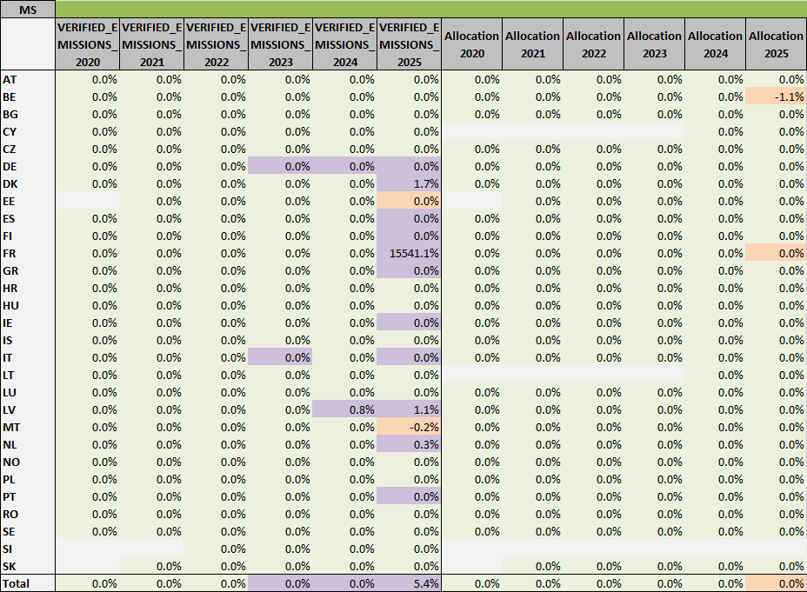
Note: Calculated as difference between July and September 2026 data
Purple: increase, light orange: decrease, green: zero difference.
Due to rounding to one decimal place, some values displayed as 0.0% may still contain very small underlying changes. Cell colours reflect the direction of these unrounded changes.
Sources: Union Registry extract 12 October 2026 and former extracts, own calculation

Verified emissions (Maritime)
In the following table, data on verified emission is compared between the datasets from September 2026 and October 2026 for maritime data. Differences are shown as percentages, calculated from the difference related to latest data.
Table 3.2 Changes in VE between datasets (stationary installations)
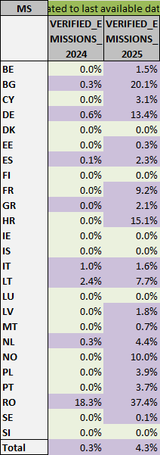
Note: Calculated as difference between July and September 2026 data
Purple: increase, light orange: decrease, green: zero difference.
Due to rounding to one decimal place, some values displayed as 0.0% may still contain very small underlying changes. Cell colours reflect the direction of these unrounded changes.

Sources: Union Registry extract 12 October 2026 and former extracts, own calculation

Gap-filling of Verified Emissions for the Latest Reporting Year
The EU ETS Registry publishes verified emission data on a rolling basis. When working with an April snapshot, a share of installations has not yet submitted their verified emissions for the most recent reporting year. To ensure comparability and completeness, a gap-filling procedure is applied to estimate the missing values.

Methodology
The gap-filling is performed at the installation level and distinguishes three sectors: Aviation (Activity Type Code 10), Maritime (Activity Type Code 50), and Stationary installations (all other codes).

For each sector, a sector-specific reduction factor is derived from all active installations that have reported values in both the previous year (2024) and the current year (2025):

Factor = Σ Emissions(2025, reported) / Σ Emissions(2024, reported)

Decommissioned installations, identified by a non-empty YEAR_OF_LAST_EMISSIONS field earlier than the current reporting year, are excluded from both the factor calculation and the gap-filling. For each active installation without a 2025 value, the expected emission is estimated as:

Emissions(2025, expected) = Emissions(2024) x Sector Factor

Results by Member State
Important note on gap-filled estimates

The Gapfilled 2025 values presented in this section are estimates based on a statistical extrapolation and do not represent officially reported data. They are intended solely to provide an early indication of emission trends before the reporting cycle is complete. The actual verified emissions for 2025 may differ, as they depend on the individual reporting of each installation. The gap-filling should therefore be interpreted as a working assumption to enable timely analysis, not as a forecast or projection of final outcomes.

Table 4.1 shows verified emissions by Member State and sector. For 2025, both the emissions already reported ("Reported 2025") and the gap-filled total ("Gapfilled 2025") are shown. The difference between the two reflects installations that were active in 2024 but had not yet submitted their 2025 verified emissions at the time of the data snapshot.

Table 4.1 Verified emissions (Mt CO2 equivalent) by Member State, sector, and year
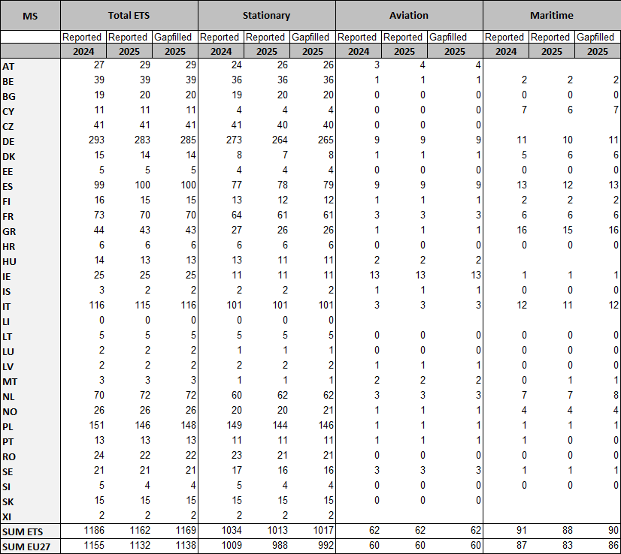
Note: Reported 2025 refers to verified emissions as submitted by entities at the time of the April 2026 data snapshot. Gapfilled 2025 includes estimated values for entities that were active in 2024 but had not yet reported at the time of the snapshot, derived by applying a sector-specific reduction factor to their 2024 emissions. Empty cells indicate that no entities of the respective sector are registered in that Member State.
Sources: Union Registry extract 12 October 2026 and former extracts, own calculation

At ETS level, reported verified emissions sum to 1 162 Mt CO₂-eq for 2025 at the time of the snapshot, compared to 1 186 Mt in 2024. After gap-filling, the estimated total rises to 1 169 Mt, suggesting that a substantial share of the apparent decline reflects incomplete reporting rather than actual closures.

