Type of Document:
“Draft internal Report” (Milestone July 2014)

Prepared by:
UBA: Gebhard Banko, Michael Weiss, Dietmar Moser
UMA: Dania Abdul Malak
UAB: Raquel Ubach
ETC-BD: Lubos Halada,
ALTERRA: Gerard Hazeau, Anne van Dorn, Wieger Wamelink, Sander Mucher, Stephan Hennekens, Joop Schaminée, Gerbert Roerink
GISAT: Tomas Soukup, Lukas Brodsky
GeoVille: Stephan Kleeschulte, Camino Liquete
Date:
31. July 2014
Project Manager:
Markus Erhard
Title: DEVELOPING CONCEPTUAL FRAMEWORK FOR ECOSYSTEM MAPPING

Subtitle: Task 184_1 ecosystem mapping
PART A – ecosystem TYPE mapping

Universidad de Malaga
ETCSIA
PTA - Technological Park of Andalusia
c/ Marie Curie, 22 (Edificio Habitec)
Campanillas
29590 - Malaga
Spain

Telephone: +34 952 02 05 48
Fax: +34 952 02 05 59

Contact: etc-sia@uma.es

Table of Contents
1 Background 2
1.1 Expected results 2
2 Links to other tasks 3
3 Approach 3
3.1 Ecosystem typology 3
3.2 Ecosystem mapping 4
4 Input data sources 9
4.1 Land Cover data 9
4.2 Base data 11
4.3 Environmental data 14
4.4 Soil data 18
4.5 Additional remote sensing data 22
4.6 Marine data 23
5 Data preprocessing 23
5.1 Elevation zone 23
5.2 WFD-river and lakes 25
5.3 Soil qualifier 27
6.2 OSM-roads and land use 30
6.3 processing of marine data 33
7 Mapping rules 33
7.1 CLC based Thematic rules 33
7.2 Phenological rules (HANTS) 39
7.3 Mixed classes (CLC 242 and 243) 45
7.4 Integrating other land cover data 47
7.5 OSM data 48
7.6 marine rules 49
8 Definition of Accuracy/Reliability 49
8.1 Geometrical reliability 50
8.2 Thematic reliability 50
8.3 Combined reliability 51
9 Technical implementation of mapping rules 52
9.1 Main input: crosswalk CLC-EUNIS 52
9.2 EUNIS habitat complexes (X) 52
9.3 Refinement of m:n relations 54
10 Results ecosystem type map 54
10.1 Version history 54
10.2 Map of ecosystem types 55
10.3 Statistic 55
10.4 Delivery Files 56
11 Appendix 58
11.1 Crosswalk MAES-EUNIS-CLC 58
11.2 Typology of ecosystems (EUNIS Level 2) and GRID Code 63
11.3 EUNIS Level 2 class descriptions 67
11.4 EUNIS habitat complexes 78
12 Annex 83
12.1 Statistic per country 83
12.2 Original CLC-EUNIS crosswalk 83
12.3 Habitats (Annex I) used for mapping EUNIS classes 88
12.4 Art. 17 distribution maps 91

Background
This task shall support EU biodiversity strategy to 2020 Target 2 Action 5 by providing conceptual framework for ecosystem mapping of ecosystem types and ecosystem condition.

Ecosystem mapping shall provide reliable information for identification of Europe’s ecosystems to be part of Green Infrastructure or to be restored (15% target).
Ecosystem mapping shall be in direct link to ecosystem services mapping (ESS) and Ecosystem capital accounts (ECA) approaches.
The framework will address:
- Ecosystem structure (by mapping of their biophysical delineation and health)
- Ecosystem functions (as predisposition to deliver ecosystem services)
The report is divided into two parts:
- Part A: ecosystem TYPE mapping
- Part B: ecosystem CONDITION mapping

PART A – ecosystem type mapping
Ecosystem classification is based on EUNIS and the proposal of ecosystem typology for the MAES working group. It takes into account mapping feasibility at European scale and keep compatibility with national mapping approaches (nested scales).
From operational point of view it applies regular mapping carried out within the COPERNICUS programme (CLC, HRLs) and reporting data flows (N2000, Art. 17, WFD, MSFD). Nevertheless, potential of existing or upcoming dynamic datasets are explored too (e.g. phonological time series using satellite data: SENTINEL data, HANTS, …).

PART B – ecosystem condition mapping
Ecosystem CONDITION indicator builds on ecosystem mapping and it provides a structured information on ecosystems health and resilience to inform policy about development of Europe’s ecosystems.

Expected results
Conceptual framework for ecosystem mapping along with a pilot Europe’s ecosystems assessment consisting of:
- Ecosystems classification (revision of 2013 classification)
- Improved Ecosystems map + method for ecosystem mapping (revision of 2013 classification)
- Collection of individual ecosystem condition indicators (in close cooperation with task 184-1-2 Ecosystem assessment)

Links to other tasks

Within the ETC-SIA close cooperation will be maintained with the following tasks:
- 184_1 Follow-up Ecosystem assessment
- 184_2 Ecosystem pressures
- 184_3 Analysis of pressures integration into ecosystem assessment
- 182_2 Impact of policy changes on net nutrient & contaminant inputs
This task is carried out in close cooperation with the ETC-BD and the following task:
- 1.2.2.B.1 “Biodiversity and Ecosystem assessments related to the EU Biodiversity strategy”

A detailed overview on the crossrelations between the above listed tasks and the distribution of work is given in the part B report.

Approach

The mapping of ecosystems is here considered at the scale of habitat/biotopes and partly on landscape level. Ecosystem mapping is the spatial delineation of ecosystems following an agreed ecosystem typology (ecosystem types).

Ecosystem typology
The typology that will be used for mapping ecosystems was developed within the MAES working group (MAES Working paper v 9.7.5). This typology groups the main EUNIS-classes into three distinct groups (terrestrial, freshwater and marine ecosystems
The MAES ecosystem typology differentiates three levels, whereas the Level 2 of the MAES proposal follows closely the EUNIS Level 1. The third level of the MAES typology corresponds therefore to the EUNIS level 2. This level will be the base for the mapping approach. Where necessary and helpful special mapping procedures may be defined as well on EUNIS level 3 (in case this allows a better regional differentiation of habitats).
Some classes can not be mapped out of the following constraints:
- Size constraints
  - As CORINE Land cover defines 25 hectares as minimum mapping unit, all features below this MMU can not be mapped with the standard CORINE Land cover data
- Data constraints
  - As the access to other geo-data is not always straight forward, some classes coul not be mapped, although data exist to differentiate these classes (e.g. data from the FWD for differentiation of J5)
- Applicability
  - Some classes are not representing land cover in the narrow sense (e.g. caves) or are out of scope of normal land monitoring data (e.g. volcanic activities)
The following table lists the classes that could not be mapped due to one of the three constraints:
EUNIS_L2_ID | ID_Grid_L2 | EUNIS_name | constraint
E5 | 27 | Woodland fringes and clearings and tall forb stands | too small
FA | 39 | Hedgerows | too small
H1 | 46 | Terrestrial underground caves, cave systems, passages and waterbodies | not applicable
H6 | 51 | Recent volcanic features | not applicable

Ecosystem mapping
The basic geometric reference for the mapping of ecosystem types is CORINE Land Cover transformed into the 100*100 m grid (using the CORINE land cover value of the pixel centroid as pixel class label). CORINE Land Cover classes are transformed into EUNIS classes based on detailed expert analysis, starting with the m:n crosswalk between EUNIS and CLC, additional georeferenced data (higher resolution compared to CLC) and thematic relation between land cover classes and the EUNIS classification system (improving the thematic resolution of CLC). The crosswalk between EUNIS classes and CORINE land cover classes was already developed from the ETC-BD and was used as starting point.
The mapping is conducted in three separate steps (see figure 1):
- Land Cover refinement (integrating land cover database with higher geometric resolution)
- EUNIS-CLC cross walk
- Thematic refinement
- Quality assessment (experimental)
Ad 1. Land Cover refinement (building a integrated land cover database):
As the origin of CORINE Land Cover is based on a visual interpretation of satellite images in scale 1:100.000 with a minimum mapping unit of 25 ha, the methodology limits the spatial scale and the spatial detail that can be reached. However due to the “GIO-Land Monitoring” more detailed land cover information is available.
Although not yet the full program of the high resolution layers (HR-layers) are already available, precursors like the soil sealing degree or the JRC-forest layer (2006) provide enhancements of the current CLC geometric resolution. Beside the HR-layers also other sectorial databases provide useful estimators for an enriched and integrated land cover map with a resolution of 100*100m (e.g. Open street map roads and Open street map land use). Those data that do not provide explicit spatial delineations (e.g. linear vectors of water courses) will not be taken into consideration for the refined land cover maps. What is needed to be integrated is a spatial explicit value for a specific land cover type that covers at least 50% of a 100*100m grid cell. This approach has been widely discussed within the HELM project (harmonized European land monitoring) as the “grid approach”.
Table: Overview of datasets to build an integrated land cover database
Theme | Dataset | Resolution/scale | coverage | comment
HR-Layer | Soil sealing 2006+2009 | 20*20m | EEA 39 | Original data in 20*20m upscaled to 100*100m, degree of soil sealing
 | JRC forest type map 2006 | 25*25 m | EEA 39 (excl. Iceland) | Classes: broadleaved, coniferous and water
Open Street Map | OSM roads | Vector data | Europe | High quality for high level roads
 | OSM land use | Vector data | Europe | Enhancement of urban areas outside CLC-urban mask
ECRINS | Water bodies |  | EU 27
Riparian areas | JRC riparian areas | 1*1 km | EU 27 | Original dataset 100*100m currently not available
Small linear features | SLF | 20*20 m | Pilot areas | Experimental dataset
HR-Layer (experimental) | Grassland | 100*100m | Pilot areas | Geoland II transect Munich-Verona
 | wetlands | 100*100m | EEA 39 | not yet available
 | water | 100*100m | EEA 39 | not yet available
EEZ (marine) | Exclusive economic zones | Vector, European scale | Europe | EEZ-world v.7 will be used, as access to ETC-ICM data can currently not be provided

Ad 2. EUNIS-CLC cross walk
The ETC-BD has developed a MS Access database for the crosswalk between EUNIS and CORINE Land cover. As these two nomenclatures are not mutually exclusive the relation between them is modelled as a m:n relation. This means that one CLC-class can contain multiple EUNIS classes and vice versa. To resolve this m:n relationship additional data have to be integrated. This step is carried out under step 3 – thematic refinement.

Ad 3 – thematic refinement:
The m:n relation expressed in the crosswalk between the EUNIS classes and CORINE Land Cover is further refined and resolved using ancillary spatially explicit data.
Box: Modelling the occurrence of habitats using predictive indicators
This approach has been chosen as well by Sander Mücher (Mücher et al. 2004) in his work on the spatial distribution modelling of selected Annex I habitats. He identified important and available environmental datasets with the highest possible accuracy for Europe and established a knowledge rule set for each habitat. The knowledge rule set was implemented as graphic decision-tree model within a GIS for each specific habitat type and lead to the assignment of three likelihood classes concerning the occurrence of each habitat type per reference grid cell (in his case 1*1 km2).

In difference to the approach of Mücher et al. 2004 (see box above) the ecosystem type mapping approach does not include any likelihood modelling. The result per pixel is not calculated as likelihood, but as hard coded decision tree. Therefore per pixel only one ecosystem type is recorded. However per pixel the reliability is recorded in addition, which reflects the geometric and thematic accuracy of the final result.
Using the ancillary datasets listed below an expert rule system is developed to define differentiations within the m:n relations between CLC-classes and EUNIS classes. The overlaps can be resolved either using geographic delineations (occurrence of special EUNIS classes in special geographic areas) or using attributive environmental specifications (occurrence of special EUNIS classes only under special environmental conditions).
Table: Overview of ancillary data used for the thematic refinement of the crosswalk between CLC and EUNIS classes
Theme | Dataset | Resolution/scale | Coverage | comment
DEM | Altitude | 100*100 m | EEA 39
 | Slope | 100*100 m
 | Aspect | 100*100 m
 | Landform | 100*100 m
DEM derivates | upper tree line | 100*100 m |  | Modelling of altitude zone montane vs. subalpine
Environmental regions | Metzger et al. | Appr. 1:1 Mio | EEA 39 (excl. Turkey, Iceland) | Environmental stratification including main climatic variables
Potential natural vegetation | Bohn & Neuhäusl | 1:2,5 Mio | Europe (excl. Turkey)
HANTS | Harmonized time series of adjusted MODIS NDVI data | 250*250 m | EEA 39 | Differentiation arable & grassland
EUSEAMAP | Marine habitat maps | Vector, European scale | Celtic, North and Baltic Seal; West Mediterranean Sea
soil | European soil type map | 1:1 Mio | EEA 39 (excl. Turkey, Iceland)
geology | EuroGeoSurveys | 1:5 Mio (geological map)  1:1,5 Mio hydrogeological map) |  | Mainly modelled within soil types, geological maps not available due to copyright restrictions

Ad 4. Quality assessment:
The quality assessment of the ecosystem map will be of experimental character. In close cooperation with the ETC-BD work package on ecosystem state assessment experimental demonstrations of using reporting obligations data (Art. 17. WFD, MSFD) will be carried out and illustrated.

An overall flow chart for the main steps of the GIS approach is given in the figure below.

Figure 1: graphical flow chart of the main steps for ecosystem mapping
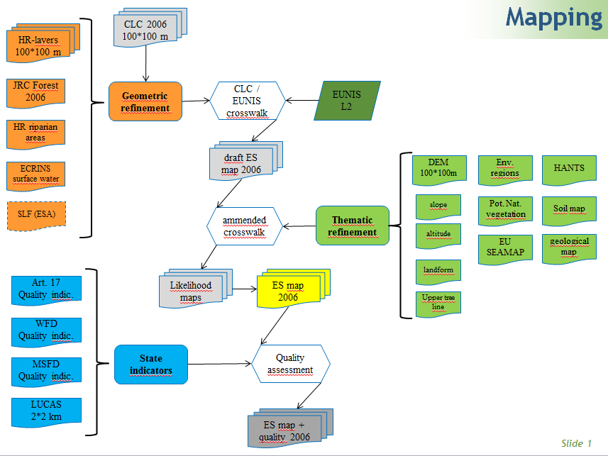

Input data sources

Land Cover data

CORINE Land Cover
  - 100m Raster version
  - Version: 16
  - file: g100_06.zip
  - Source: EEA-dataservice, 4/2012
- Missing countries: Greece
  - Greece was replaced with CLC 2000 data, as this dataset represents the best available knowledge on European level
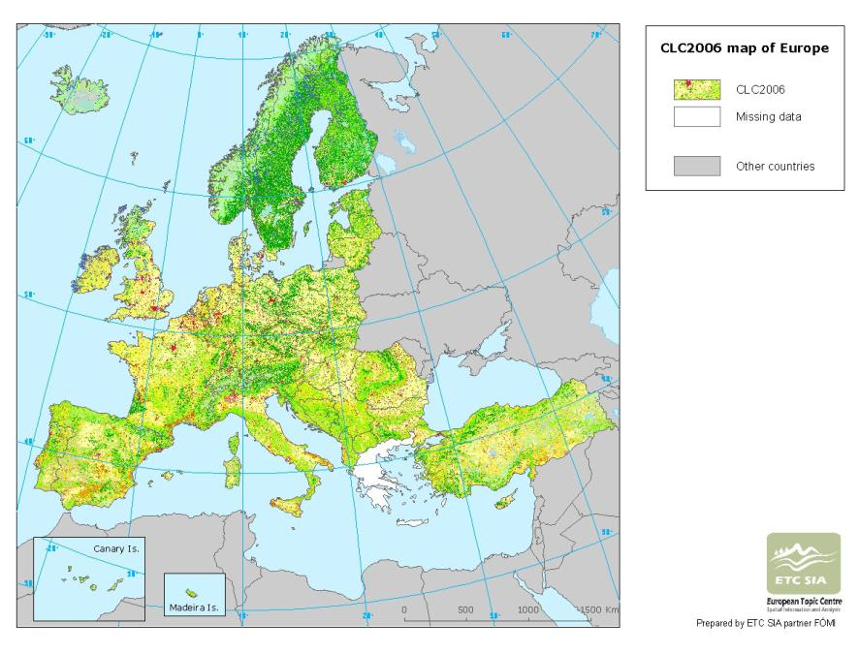

JRC Forest 2006
  - 25m Raster version
  - Files:
    - Forest TYPE MAP 2006
      - Broadleaved & coniferous
      - Water
  - Other available data:
    - MSPA (morphological spatial pattern analysis)
      - Various landscape pattern characteristics
    - MAP
      - Forest/non-forest differentiation
  - Reference year: 2006
  - Source: WWW-Download: http://forest.jrc.ec.europa.eu/download/data/
    - 23 tiles
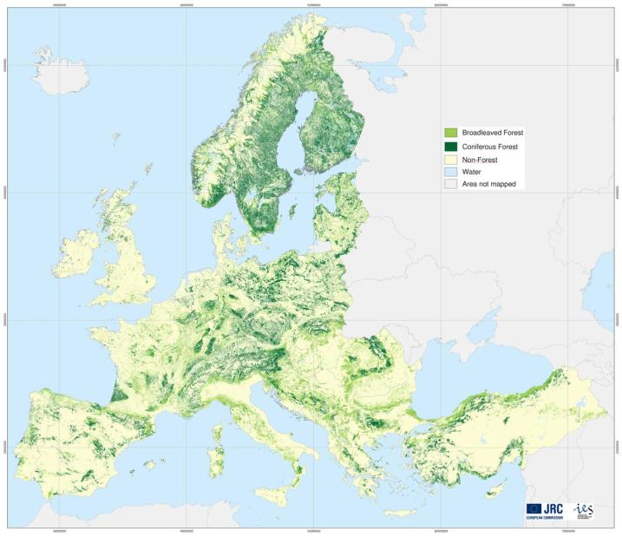

Soil Sealing
  - HRL precursor soil sealing
  - File:
    - 100m Raster
    - 20m Raster
  - Reference year: 2006
  - Version: 2
  - Source: EEA dataservice
http://www.eea.europa.eu/data-and-maps/data/eea-fast-track-service-precursor-on-land-monitoring-degree-of-soil-sealing#tab-european-data
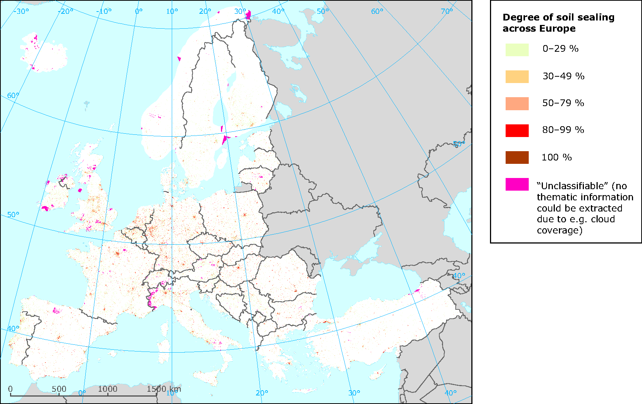

Open Street Map
  - Lines: roads
  - Polygons: land use
  - Download date: 26. June 2013
  - Source:
    - Europe (except Germany, France)
      - http://download.geofabrik.de/europe.html
    - Germany and France:
    - http://osmdata.thinkgeo.com/openstreetmap-data/europe/
  - Selection and Conversion with FME

Base data

EU-DEM
- File: dem_100_int
- Resolution: 100*100m
- Attributes: altitude, slope, aspect
- Source: UMA, EEA SDI via FTP, https://sdi.eea.europa.eu/
- Delivery: 19. March 2013
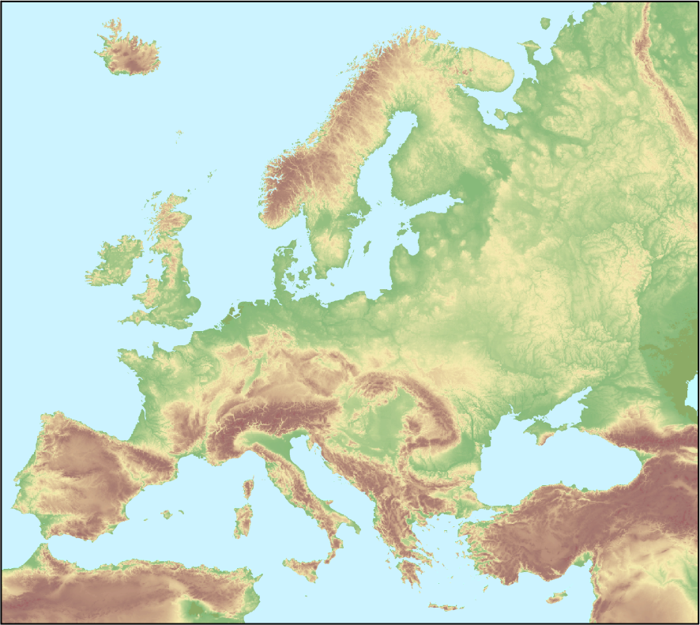

WFD rivers and lakes
NEW in 2014!
- Rivers
  - File: WFD_SurfaceWater_LAEA.gdb
  - Water_body_ecological_status_or_potential_River
- Lakes: ETC_SIA_lakes_Banko.shp
  - Retransmitted from SWB_LW (standing water body_lake water) including the attribute NATURAL
- Resolution: lines (rivers) and polygons (lakes)
- Attributes: NATURAL
- Source: EEA SDI via transfer link Delivery:
  - 12. February 2014 - rivers
  - 4. March 2014 - lakes

For differentiating water courses and lakes into rather natural ones and heavily modified water courses/bodies the information from the WFD is required.
For every water body the attribute “naturalness” is documented in the WFD with the following attributes:
- Natural
- Artificial
- Heavily modified
The information is necessary to differentiate between normal water bodies” C1 /C2 semi-natural water body” and “J5 heavily artificial man made waters”.

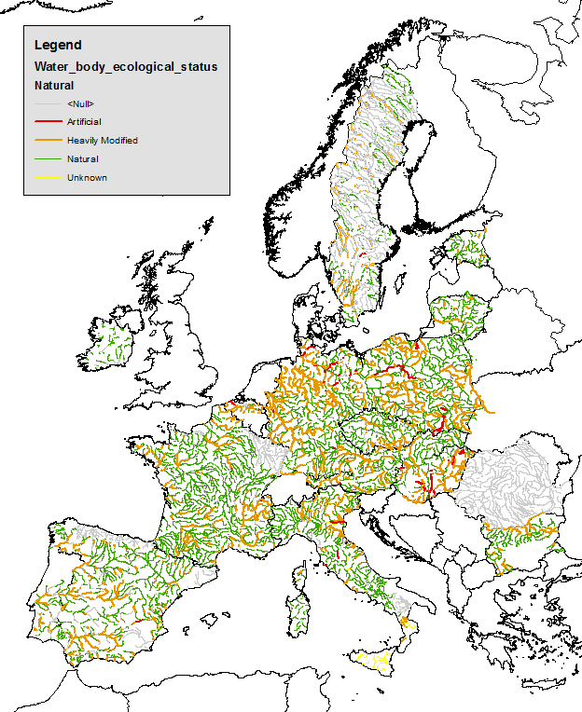
Figure: Map of Europe containing information on the naturalness of rivers.

Environmental data

Natura 2000 Art. 17 report
File : Art. 17 reporting database (report 2013)
Source : ETC-BD
Description : The art. 17 report within the habitat directive contains distribution maps for the Annex I habitat types with a 10*10 km resolution. Those habitat types that are of relevance for the thematic rules to refine the m:n relations between EUNIS and CLC are given in the Annex. In total 63 habitat types mainly part of the categories “coastal”, “bogs and mires” and “shrubs” were integrated.
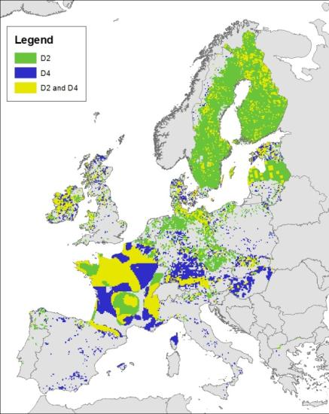
Figure: example of distribution of D2 (7140) and D4 (7210, 7220, 7230).
group | Annex_I | habitatname | ES_L2
D - bogs_mires | 7140 | Transition mires and quaking bogs | D2
D - bogs_mires | 7210 | Calcareous fens with Cladium mariscus and species of the Caricion davallianae | D4
D - bogs_mires | 7220 | Petrifying springs with tufa formation (Cratoneurion) | D4
D - bogs_mires | 7230 | Alkaline fens | D4

Environmental regions

- File: enz_v8
  - ENS…environmental strata (84 types)
  - ENZ…environmental zones (13 types) used
- Source: direct contact to Marc Metzger (Johannes Peterseil)
  - Date: Jan. 2009
- Description:
Environmental zones based on the Environmental Stratification of Europe Version 8 (Metzger et al. 2005).
The environmental stratification does not cover Iceland and Cyprus and does not cover completely Turkey.
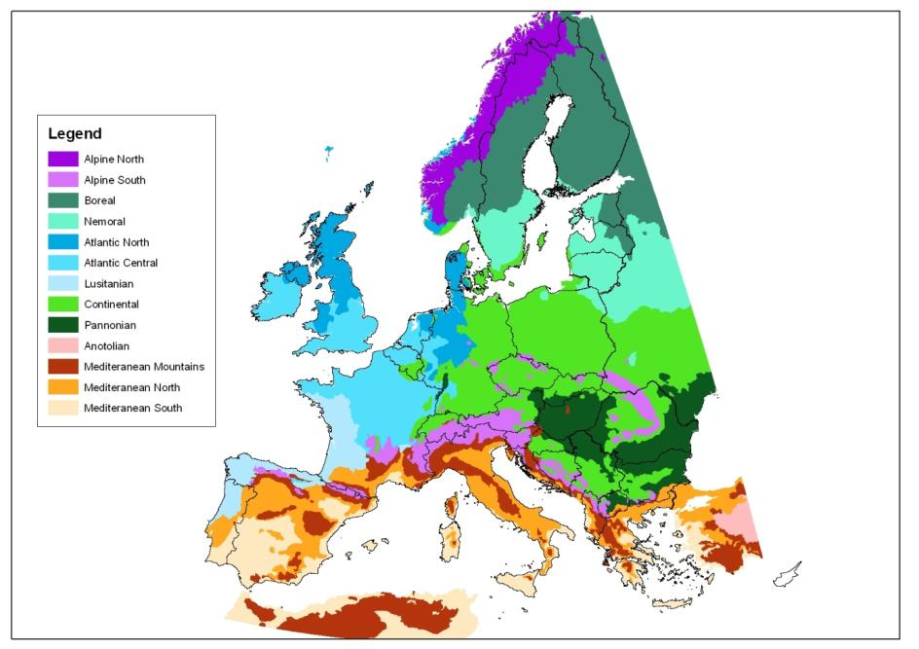
Figure 1: Environmental Zones in Europe

- European integration
  - As Turkey was partly missing in the dataset of Environmental zones the file was amended with the Turkish environmental ecoregions
    - File: Turkey_Ecoregion.mdb
    - Source: EEA-project on HNV farmland
    - Attributes: The file contains the 8 major regions that are subdivided into 21 divisions
Figure: Environmental Ecoregions of Turkey
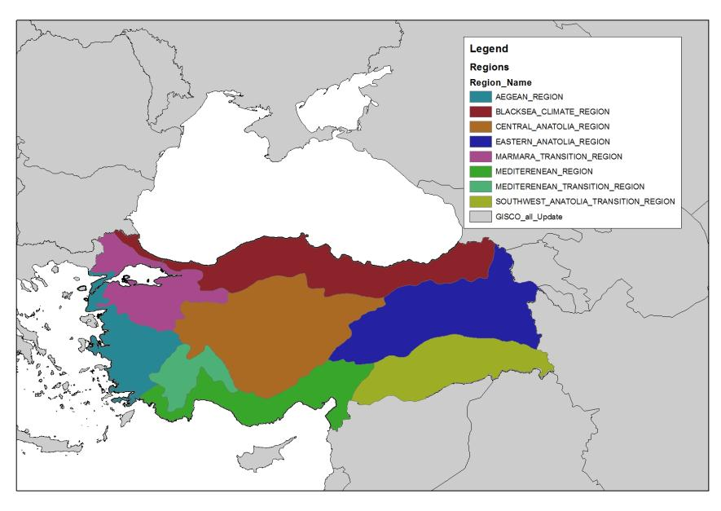
- Preprocessing:
  - The outline of the Turkish environmental zones were visually adapted to represent the CORIEN Land cover sea shore
  - The major regions are transformed into the classes of the comparable environmental zone.
Code | Environmental strata (Metzger) | Turkish ecoregions
MDM | mediterranean mountains | black sea region
 |  | mediterranean transition region
MDS | mediterranean south | mediterranean region
ANA | anatolia | central anatolian region
 |  | estern anatonlian region
 |  | southwest anatolian transition region

  - The global version of the environmental zones (GEnSv3_11012012) were tested, but lead to higher inaccuracies compared to the combined result of the two datasets above.

Potential natural vegetation

- Scale: 1:2,5 Mil
- Source: BfN, BOHN & NEUHÄUSL 2000/2003
  - 2004 , CD-ROM, ISDN: 3-7843-3848-8
- Download: EuroVegMap 2.0.6
  - http://www.floraweb.de/vegetation/dnld_eurovegmap.html
- Missing countries: turkey, Cyprus
- 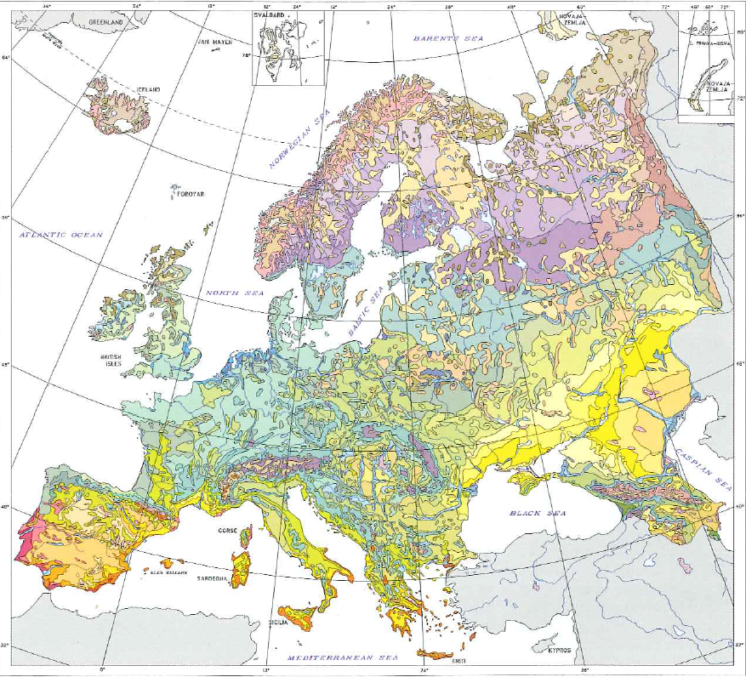

Soil data

Top Soil organic carbon
- File: octop_insp
- Format: INSPIRE-Grid, 1*1 km
- Attribute: percentage of organic carbon in top soil
- Source: JRC-download, April 2012
References:
- Jones R.J.A., Hiederer R., Rusco E., Montanarella L. Estimating organic carbon in the soils of Europe for policy support (2005) European Journal of Soil Science, 56 (5), pp. 655-671.
- Panagos, P., Van Liedekerke, M., Montanarella, L., Jones, R.J.A, Soil organic carbon content indicators and web mapping applications, Environmental Modelling & Software, Volume 23, Issue 9, September 2008, Pages 1207-1209.
- Jones, R.J.A., Hiederer, R., Rusco, E., Loveland, P.J. and Montanarella, L. (2004). The map of organic carbon in topsoils in Europe, Version 1.2, September 2003: Explanation of Special Publication Ispra 2004 No.72 (S.P.I.04.72). European Soil Bureau Research Report No.17, EUR 21209 EN, 26pp. and 1 map in ISO B1 format. Office for Official Publications of the European Communities, Luxembourg.
- Panagos P., Van Liedekerke M., Jones A., Montanarella L. European Soil Data Centre: Response to European policy support and public data requirements. (2012) Land Use Policy, 29 (2), pp. 329-338. doi:10.1016/ j.landusepol.2011.07.003
Figure: Top Soil organic carbon content (%)
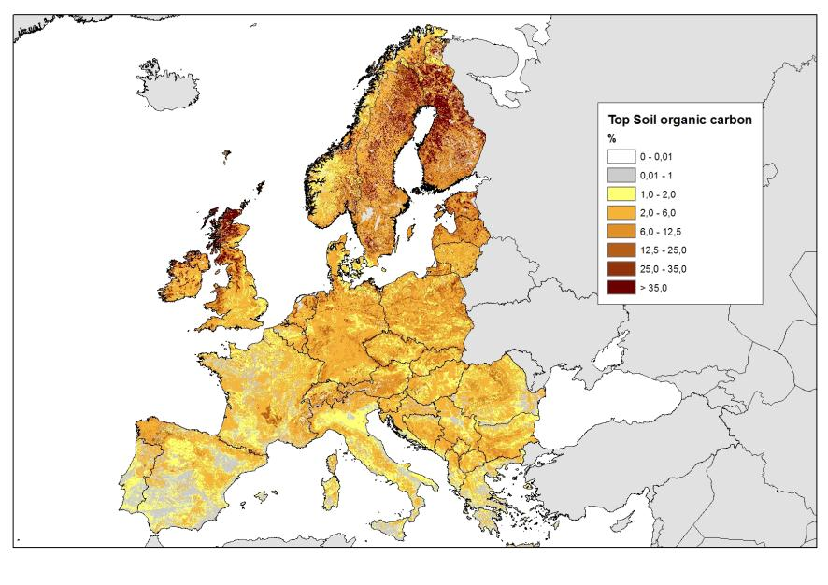

European Soil database (ESDB)
- File: ESDB v2 (1*1 km2)
- Format: INSPIRE-Grid, 1*1 km
- Attributes:
  - Dominating parent material (DOMPAREM)
  - Topsoil base saturation (BS_TOP)
- Source: JRC, download August 2013
  - http://eusoils.jrc.ec.europa.eu/ESDB_Archive/ESDB_data_1k_raster_intro/ESDB_1k_raster_data_intro.html
- References:
  - Panagos P., Van Liedekerke M., Jones A., Montanarella L. European Soil Data Centre: Response to European policy support and public data requirements. (2012) Land Use Policy, 29 (2), pp. 329-338. doi:10.1016/j.landusepol.2011.07.003
  - ESDBv2 Raster Library - a set of rasters derived from the European Soil Database distribution v2.0 (published by the European Commission and the European Soil Bureau Network, CD-ROM, EUR 19945 EN); Marc Van Liedekerke, Arwyn Jones, Panos Panagos ; 2006.
  - Panagos Panos. The European soil database (2006) GEO: connexion, 5 (7), pp. 32-33.
Figure: Top soil base saturation in three classes (High, medium, low)
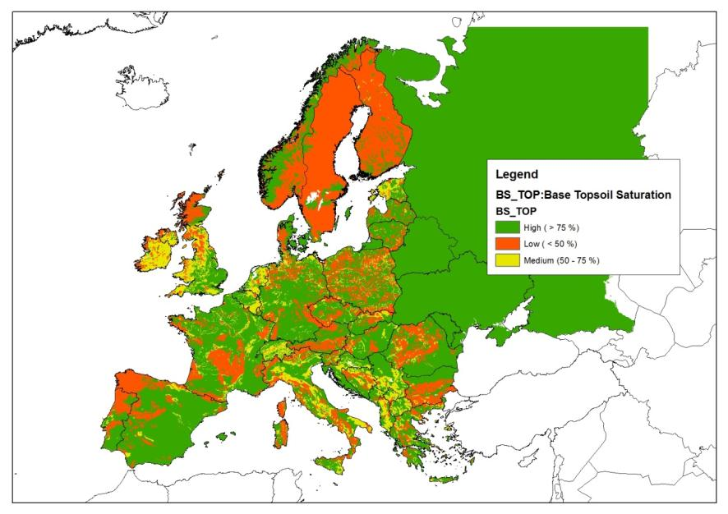

Field capacity
- File: fieldcapacity.asc
- Format: INSPIRE-Grid, 1*1 km
- Attribute: field capacity (divide by 100 to get mm/m)
- Source: EEA via FTP-download, June 2013

Figure: Field capacity in mm/m
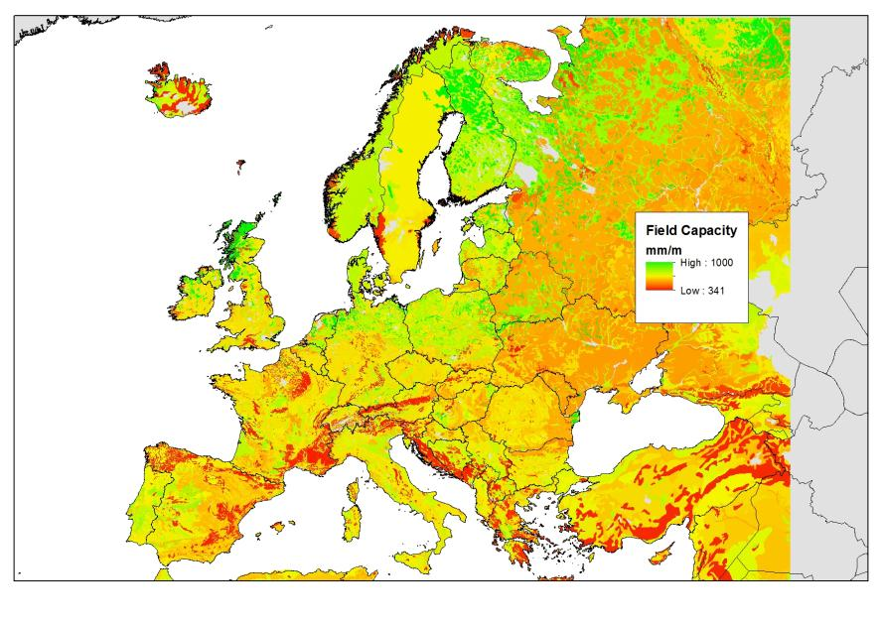

Soil water balance
- Files: WB200501000.asc.gz WB20071200.asc.gz
- Format: INSPIRE-Grid, 1*1 km
- Attribute: mm of water at the end of the month, monthly values years 2005-2007
- Source: EEA via FTP-download, June 2013
- Preprocessing:
  - Calculation of MEAN water balance per year
  - Selection of year 2005 as representative year for further processing

Figure: Mean soil water balance in 2005
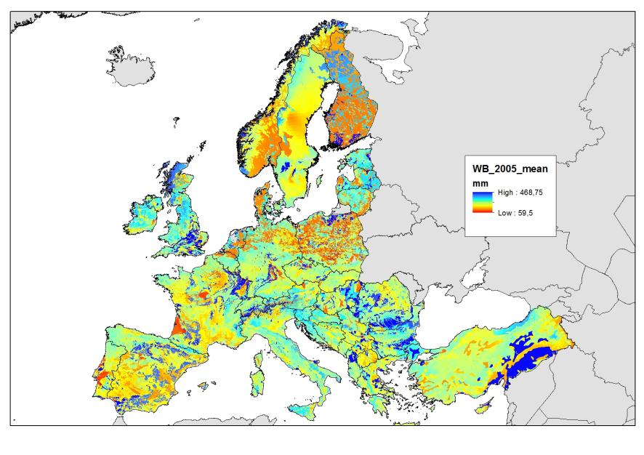

Additional remote sensing data

HANTS/MODIS
The temporal development of phonological indicators can be observed with remote sensing data providing a very high temporal resolution. Unless the SENTINEL 2 data are available the current freely available dataset are restricted in their spatial resolution to >= 250m pixel sizes. MODIS with a daily revisit time and a spatial resolution of 250meter is well suited for NDVI analysis. The seasonal cycle of the NDVI can be approximated by a limited number of frequeny components derived from a Fourier analysis. This principle is implemented in the HANTS algorithm (Harmonic Analysis of NDVI Time Series) which employs an interative routine to filter out poor NDVI estimates due to cloud dover or other disturbances from the NDVI cycle. The basic concept behind the algorithm is that the vegetation development as indicated by the NDVI has a strong seasonal effect in most parts of the worl which can be described using a series of low frequency sine functions with different phase, frequencies and amplitudes (Alterra report 2259, 2012).
The HANTS yearly data series is available
Phenological indicators:
NDVI: mean, maximum and minimum
Seasonal Dates: start of Season (SOS), peak of season (POS), End of season (EOS), Low of season (LOSI
Data preparation: ALTERRA, Gerbert Roerink

Figure: HANTS phenology: mean NDVI in 2011
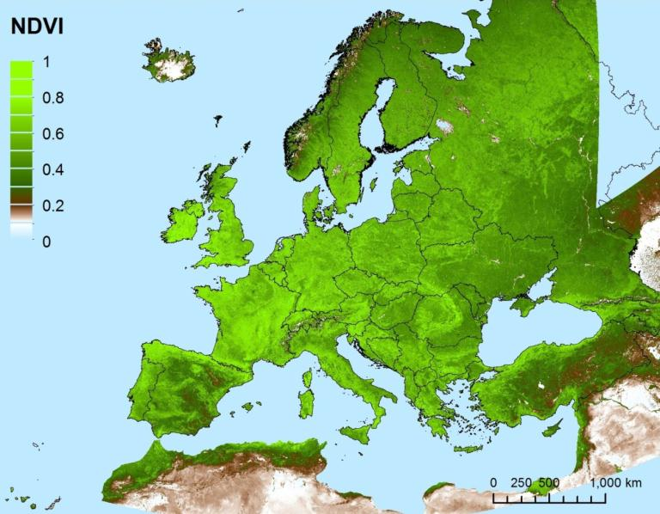

Marine data
To be COMPLETED by RAQUEL

Data preprocessing
All input data were rasterized to the standard 100*100m INSPIRE raster grid.
Various preprocessing steps were necessary to prepare the data for their integration into the ecosystem mapping workflow.

Elevation zone
Two ecosystem types are defined according to the alpine and subalpine elevation zone. However no European wide data existed for these elevation zones that are not strictly defined by the altitude but rather include complex altitudinal, geomorphological and climatic parameters.
altitudinal zonation | height
planar | < 300m
colline | 250-700 m
submontane | 500-1000 m
montane | 800-1400 m
high montane | 1200-1800
subalpine | 1500-2500 m
alpine | 1700-2800m
nival | >2800 m

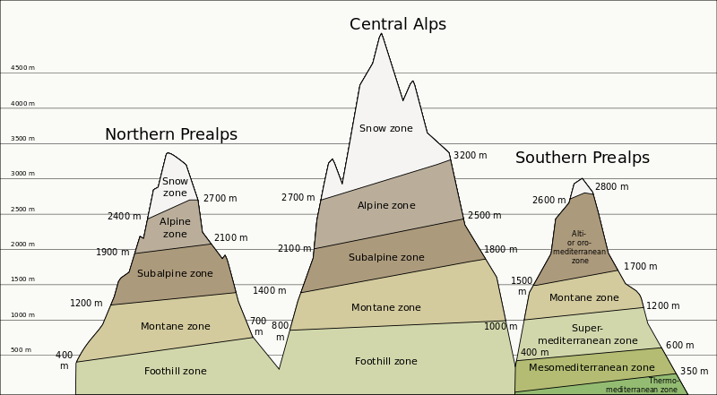Source: http://en.wikipedia.org/wiki/Altitudinal_zonation
- Fleurs de montagne, Jean-Marie Polese, Artémis Editions 2008
- Fleurs des Alpes, balade d'un botaniste des paines aux sommets, François Couplan, Nathan, 2005
- Author: Pethrus

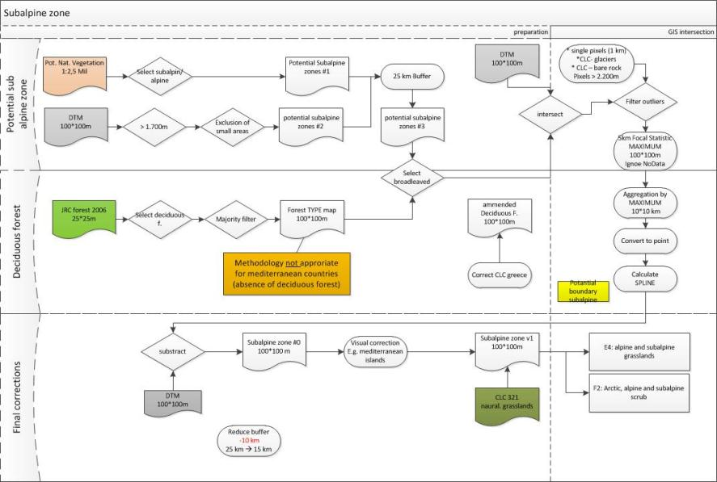

WFD-river and lakes

Rivers
The information on rivers is available as lines. Therefore they have been converted into a 100*100m grid file with the attribute NATURAL.
Attribute NATURAL | CODE Grid file
Artificial | 3
Heavily modified | 2
Natural | 1
NULL + unknown | 9
NoData | 0

As geometric uncertainties between the delineation of rivers in the WFD- dataset and the geometric delineation of rivers in the CORINE Land Cover dataset influence the results, the line-geometry of the WFD-data have been extended by 5 pixels (in each direction). It is important to note that the geometric information on land cover is still derived from CORINE Land cover, but the thematic information is derived from the WFD. Therefore the buffer of 5 pixels does not influence the geometric results.
CLC-data | CLC data superimposed with WFD-river segments (blue)
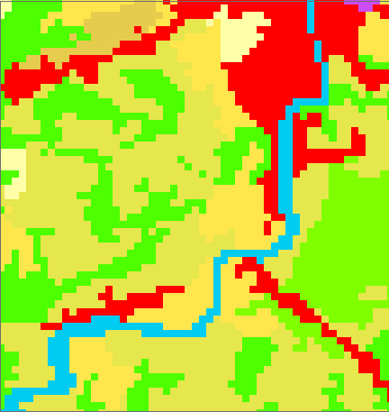 | 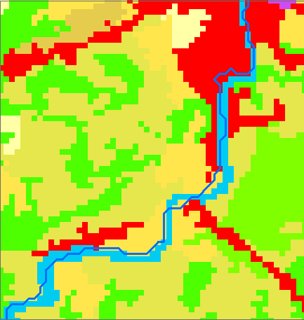
Extraction of CLC water surface with WFD-river (blue) | 5-Pixel Buffer of WFD-river line superimposed on CLC water surface
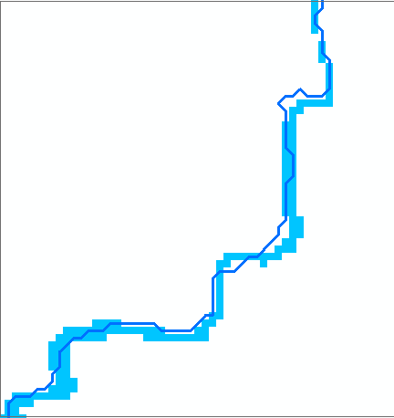 | 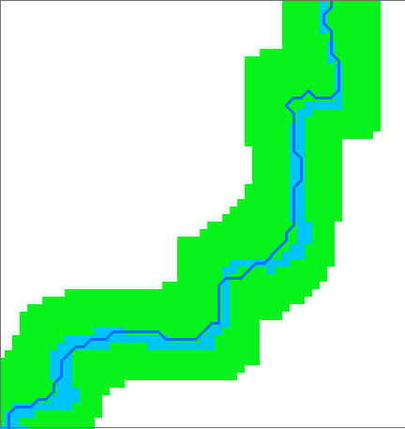

Figure: Illustration of geometric differences between CORINE Land Cover and WFD river segments (example: river Enns, nearby city Steyr, Austria)

Lakes
The information on lakes is available as polygons with the same attribute coding as rivers (see above for GRID-coding table).
As the lake boundary can be quite different from the lake boundary in CORINE Land cover the buffer of 5 pixels has been included for the processing of the thematic attributes. Similar to the rivers this does not affect the geometric results.

Soil qualifier

wetness
The workflow for differentiating grasslands includes the following environmental qualifiers
- Elevation zone
- Soil wetness
- Phenology
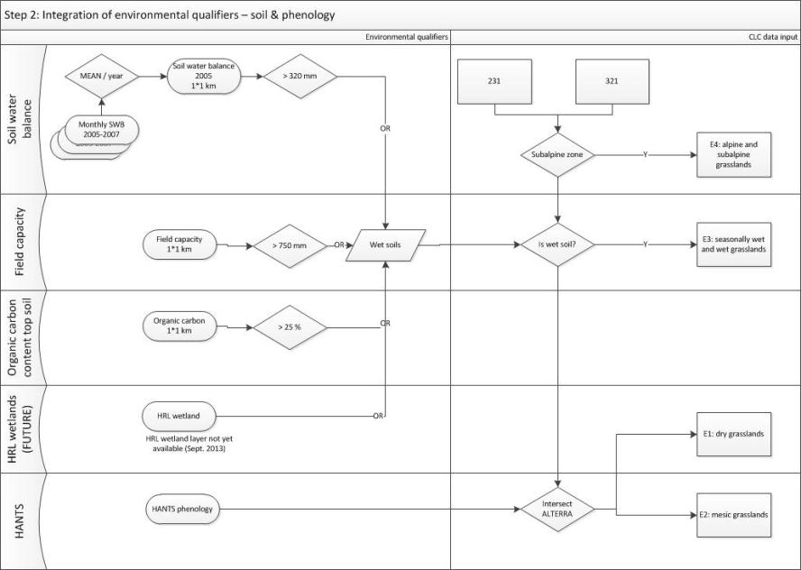

The environmental qualifier subalpine zone is described in detail in the sub-chapter and is used to differentiate the alpine grasslands from the CLC classes “231 pastures” and “321 natural grassland”. The wet grasslands are separated using soil information. As last part of the differentiation process the remaining grasslands are splitted into dry and mesic grasslands according to their phenological characteristics.

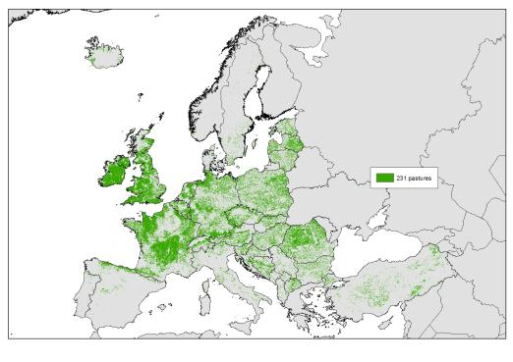  CLC classe 231 pastures | 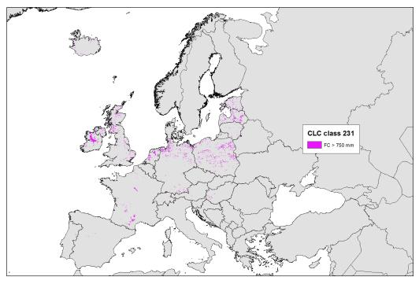  CLC classe 231 and field capacity > 750 mm/m
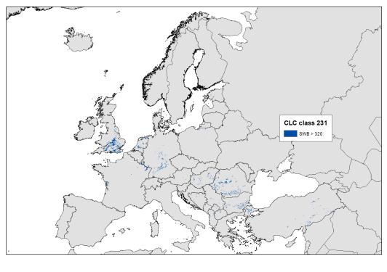  CLC classe 231 and soil water balance 2005 > 320 mm | 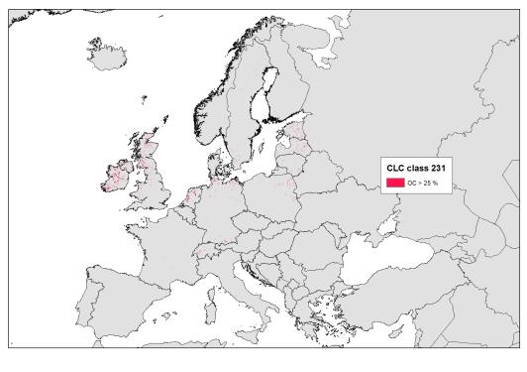  CLC class 231 and organic content > 25%
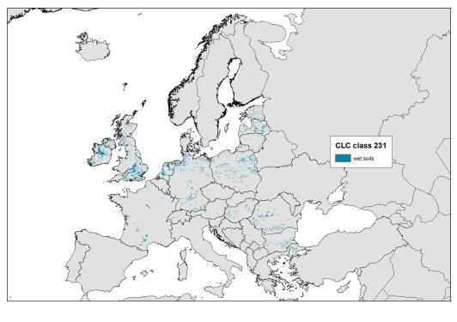
CLC class 231 and combined wet soils

Transformation table used for soil wetness:

soil_wetness VALUE | old VALUE | COUNT | FC_750 | SWB_2005_320 | OCTOP_25
0 | 1 | 13999558 | 0 | 0 | -1
0 | 2 | 12646815 | 0 | 0 | 0
1 | 3 | 425976 | 1 | 0 | -1
1 | 4 | 647033 | 1 | 0 | 0
1 | 5 | 180348 | 0 | 1 | 0
1 | 6 | 178476 | 0 | 0 | 1
1 | 7 | 114741 | 1 | 0 | 1
1 | 8 | 943 | 0 | 1 | 1
1 | 9 | 21 | 1 | 1 | 1
1 | 10 | 111 | 1 | 1 | 0
1 | 11 | 60570 | 0 | 1 | -1

Description:
- Soil wetness value: VALUE in GRID “soil_wetness”
  - VALUE >0 ….wet soils
  - CODING: 100…field capacity, 10…soil water balance, 1…organic content
- Old VALUE: automatic value after COMBINE
- FC_750: field capacity > 750 mm
- SWB_2005_320; soil water balance 2005 > 320 mm
- OCTOP_25: top soil organic carbon > 25%

Acidity of soils
Temperate shrub heathland (F4) only occure on acid soils. As proxy indicator for acid soils the base saturation can be used. The direct relation between the base saturation and the pH-value of soils is given in the table below:

Table: relation between base saturation and ph-value
Base saturation (BS) |  |  | pH – Value  (CaCl2)
Code | Soil base-saturation | in %
BS1 | Very low | <5 | <3,3
BS2 | Low | 5-<20 | 3,3-<3,8
BS3 | intermediate | 20-<50 | 3,8-<4,8
BS4 | High | 50-<80 | 4,8-<6,0
BS5 | Very high | 80-100 | >=6,0

This relation is used to reclassify the chemical attribute “base saturation in top soils” of the European Soil database. A base saturation below 50% is regarded as acid and is used as additional criteria to differentiate F4 from other heathlands.
Table reclassification of Top soil base saturation in ESDB
ESDB-European soil database |  | Ecosystem mapping
Base saturation top soil | in % | Reclassification
Low | < 50 % | Acid
Medium | 50-75 % | -
High | > 75% | -

OSM-roads and land use
The open street map data include more detailed than CORINE Land Cover the main roads and as well built-up areas. For roads only the main roads (highways) were selected, as they establish the main land cover per 100*100 pixel. The average percentage of a road in a 100*100m pixel can be estimated with 50-60% (4 lane or 6-lane road).
For land use the OSM data includes already delineated polygons for land cover. The dynamic of the dataset can be clearly demonstrated, as two years ago the land use in open street map was a simple copy of the CORINE Land cover dataset. But nowadays much smaller features than in CORINE Land Cover (25 ha MMU) are mapped. Therefore the relevant classes were extracted from the OSM land use

With of roads and dominant land cover
Due to the analysis of the OSM-road dataset in the 2013 report only the road type “motorway” was selected as dominating land cover on the level 100*100m pixel (refer to 2013 report for details). A motorway is normally characterized by in minimium 2 lanes per direction. This leads to a total width of the road including side constructions or approximately 50m and more. Therefore the normal motorway can be regarded as dominating land cover feature per 100*100m cell.

The following OSM road types were selected from OSM.
FREQUENCY | TYPE | selected
153025 | motorway | x
134031 | motorway_link | x

4-lane highway (width of lanes: 23 m, including side constructions: 40m-60m, average sealing degree (100*100m: 10-50%)) | 6-lane highway (width of lanes: 33m, , including side constructions: 50m-70m, average sealing degree: (100*100m) 30-60 %)
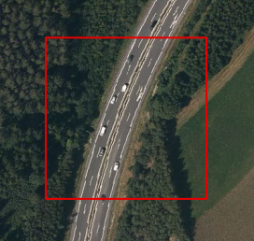 | 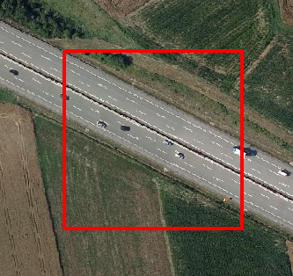

OSM and land use data
The following land use types were selected from OSM and mapped towards EUNIS classes:
TYPE | ID_ES_OS | EUNIS_L2 | EUNIS_L3 | Count
village_green | 10 | I2 | I2.1 | 24608
park | 10 | I2 | I2.2 | 73
cemetery | 10 | I2 | I2.3 | 90452
retail | 21 | J1 | J1.1 | 28087
residential | 21 | J1 | J1.2 | 745046
industrial;retai | 21 | J1 | J1.3 | 385
industrial | 21 | J1 | J1.4 | 81570
commercial | 21 | J1 | J1.5 | 21374
allotments | 22 | J2 | J2.1 | 58054
Industrial* | 23 | J3* | J3.1 | 32227
railway | 24 | J4 | J4.1 | 4612
reservoir | 25 | J5 | J5.1 | 107472
- * Not used, due to multiple coding

An evident problem in open street map is the varying quality of the data. The quality varies between countries and within the countries, even very locally different qualities of mapping can be found. But overall the quality has improved dramatically over the last two years.
Overall the geometric quality of the objects that are integrated in OSM is quite high, but the completeness is still beyond app. 85%.

OSM.-land use: very detailed delineation almost of single houses | OSM-land use: locally varying quality and completeness of built-up data
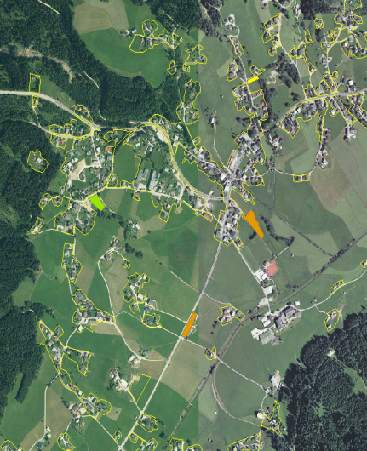 | 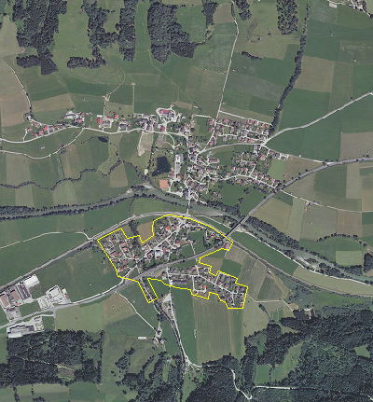

Soil sealing data
The HRL soil sealing dataset was converted into a 100*100m dataset using an average sealing degree per pixel. According to the sealing density the following EUNIS classes were derived:
Sealing degree | EUNIS class code | EUNIS class name
51-100 | 54 | Buildings of cities, towns and villages
25-50 | 55 | Low density buildings

processing of marine data
to be completed by RAQUEL

Mapping rules
The major details for mapping ecosystem types according to MAES Level 1+2 that are explained by EUNIS Level 2 classes are given in the crosswalk table in the Annex (crosswalk MAES-EUNIS-CLC).

As CORINE Land cover represents a geometrically quite coarse dataset, all kind of relevant GIS layers that provide better geometric quality are handled first. This leads to the following priority list of GIS layers:
1. HRL forest layer
- forest layer applied only outside CLC-forest
2. OSM roads
3. OSM land use
- OSM land use only outside CLC-urban and with sealing > 30%
4. HRL sealing
5. CLC-based thematic rules

CLC based Thematic rules

324 transitional woodland (G5)
Update 2014!
In Version 1.4 of the ecosystem type map a rule using the tree cover density (<30%) was applied to differentiate woodlands from dry grasslands. This rule turned out not to be helpful, as the JRC tree cover density underestimates the tree cover density, and thus large parts of the CLC-class “324 transitional woodlands” were converted into “E1 dry grasslands”. However they should be mapped as “G5 Lines of trees, small anthropogenic woodlands, recently felled woodland, early-stage woodland and coppice”.
Therefor the 30% rule for tree cover density was deleted and the whole CORINE Land Cover class 324 is mapped as “G5”.

D1, D3: Bogs and Mires (CLC 412)
D1 | Raised and blanket bogs | Peatlands formed by ombrotrophic acid peat, which is (or was while actively growing) capable of growth fed by rainfall rather than by the inflow of water from higher ground in the vicinity.
D3 | Aapa, palsa and polygon mires | Patterned mire complexes of the arctic, subarctic and northern boreal zones.

Main issue: differentiation between
  - D1 Raised and blanket bogs
  - D3 Aapa, palsa and polygon mires

These two types are summed up in the CLC class 412 (peatbogs)
Methodology:
- The first step is based on biogeographic regions. D3 does not occur outside Boreal, ALPN (within the Scandinavian region and Arctic) region.
- It means, outside FI, SE (and NO), the situation is clear, but in these countries the ancillary data should be used. These habitats occur in complexes where it will be difficult to distinguish them without detailed field data.
  - Sweden:
    - Blanked bogs are extremely rare in ALPN and their sites are probably well known – the map of Annex habitat type 7230 in SE improves the data situation.
    - The raised bogs in boreal zone of SE are quite sparse and the habitat maps of the Annex habitat type 7110 are of major help;
  - Finland:
    - FI is more complicated as both raised bogs and Aapa mires are quite widespread.
- Option: One possibility that needs to be discussed with people that have personal experience with these habitat is possible use of the micro-and meso-relief (e.g. convex of raised bogs, concave of Aapa mires; and “grain” – dimension of relief structures). It looks, D3 contain bigger structures (like “ridges”, “hummocks”) than D1 but for these micro-climatic conditions a very detailed DEM from LIDAR is necessary (not available in Europe)

D2, D4, D5 and D6: mires
D2 | Valley mires, poor fens and transition mires | Weakly to strongly acid peatlands, flushes and vegetated rafts formed in situations where they receive water from the surrounding landscape or are intermediate between land and water. Included are quaking bogs and vegetated non-calcareous springs. Excluded are calcareous fens (D4), and reedbeds (C3, D5).
D4 | Base-rich fens and calcareous spring mires | Peatlands, flushes and vegetated springs with calcareous or eutrophic ground water, within river valleys, alluvial plains, or on hillsides. As in poor fens, the water level is at or near the surface of the substratum and peat formation depends on a permanently high watertable. Excluded are reedbeds (C3, D5).
D5 | Sedge and reedbeds, normally without free-standing water | Sedge and reedbeds forming terrestrial mire habitats, not closely associated with open water. Excluded are reedbeds and sedges where they form emergent or fringing vegetation beside water bodies (C3.2).
D6 | Inland saline and brackish marshes and reedbeds | Saline wetlands, with closed or open vegetation, which are the non-coastal analogue of coastal saltmarshes and saline reedbeds (A2.5). Drier saline habitats are classified as inland salt steppe (E6) or saline scrubland (F6.8).

Geology and/or soil maps can be used for distinguishing between D2 and D4:
- D4 are calcareous while D2 acid or neutral.
- For delineation of D2 and D4 against D5 and D6 see text to D5 and D6 below.
In main part of EU probably D2 and D4 are well mapped, so the ancillary data could be used. These units include Annex I habitats 7140, 7150 (both D2), 7230 and 7240 (both D4). Probably Annex I habitats cover better D4 than D2, but I am not able to estimate how big part of D2 and D4 distribution is in Annex I. But maps of Annex I habitats could be used at least for testing purposes.
Note: It is very probable that at least some /possibly majority or all/ patches of D2 and D4 were mapped in class 412. The definition of 411 clearly covers also D2 and D4, question is if the interpreters were able to distinguish between bogs and fens. The unit D2 is particularly problematic as it contains transitional mires that probably cannot be distinguished from bogs without the ancillary data. It would be more appropriate classification of units D1-D6 into 2 classes could be 412 Bog and fens containing D1-D4 and 411 Inland marshes containing D5 and D6. But it is not possible to change the definitions, CLC1990-2006 were mapped using existing definitions and thus our situation is more complicated. Let’s suppose that 411 and 412 were classified correctly or if we found better approach to distinguishing between units, we can do/propose corrections.

- D6 is existing only in very small and rare areas and can be approximated with the distribution of Art. 17 data
- The next rare class is D5 and can as well be approximated with the Art. 17 data distribution
- D2 within Art. 17 distribution without the occurrence of D4
- D4 within Art. 17 distribution without the occurrence of D2

E1-E4: Grassland (CLC 231)
E1 | Dry grasslands | Well-drained or dry lands dominated by grass or herbs, mostly not fertilized and with low productivity. Included are [Artemisia] steppes. Excluded are dry mediterranean lands with shrubs of other genera where the shrub cover exceeds 10%; these are listed as garrigue (F6).
E2 | Mesic grasslands | Lowland and montane mesotrophic and eutrophic pastures and hay meadows of the boreal, nemoral, warm-temperate humid and mediterranean zones. They are generally more fertile than dry grasslands (E1), and include sports fields and agriculturally improved and reseeded pastures.
E3 | Seasonally wet and wet grasslands | Unimproved or lightly improved wet meadows and tall herb communities of the boreal, nemoral, warm-temperate humid, steppic and mediterranean zones.
E4 | Alpine and subalpine grasslands | Primary and secondary grass- or sedge- dominated formations of the alpine and subalpine levels of boreal, nemoral, mediterranean, warm-temperate humid and Anatolian mountains.

Input: CLC 231+321
Main idea:
- Soil parameters are an indication for wet grassland

ADD the CLC mixed categories – differentiated according to cropland and grassland
- Substract the subalpine and alpine grasslands using the subalpine height zone
- Substract the WET grasslands
  - Using soil data (combine parameters with OR)
    - Soil water balance high
    - Field capacity high
    - Organic content in top soil high
    - Evtl. High SWB and low FC
- Differentiate DRY and MED using HANTS

F3, F4: Temperate scrub and shrub heathland (CLC 322 and 331)
The temperate shrublands F3 and F4 belong to the exactly same CLC-class (322 and 331).

F4 is dominated mostly by ericoid plants, but not exclusively: dominants could be Erica, Vaccinium, Calluna, Ulex, Genista, but also e.g. Molinia, Pteridium
Potential vegetation of Europe can be used – the unit E “Atlantic dwarf shrub heaths” corresponds to F4. There is of course limitation of scale and the fact that this is potential vegetation - many heaths in Europe are of secondary origin.
The regional approach can help a little – F4 is distributed mostly in Atlantic region. More rarely it occurs outside Atlantic, in sub-Atlantic region, and here it can be found in quite large part of Europe – and this limits possibility to use regional approach.

With regard to soils pH is relevant, as F4 occurs exclusively on acid soils, this can be used as one of determinants of its distribution.

relevant Annex I habitats:
F3: 5110, 5120, 5130. Only small part of F3 is covered by Annex I habitats.
F4: 2310, 2320, 4010, 4020, 4030, 4040, 4050: quite large part of F4 is included in Annex I.

Remark: it has to be analyzed in which way the montane elevation zone within the Mediterranean strata might be used for differentiatin F3.

F5-F8: Maquis, Garrigue and Mediterranean heath (CLC 323)
F5 | Maquis, arborescent matorral and thermo-Mediterranean brushes | Evergreen sclerophyllous or lauriphyllous shrub vegetation, with a closed or nearly closed canopy structure, having nearly 100% cover of shrubs, with few annuals and some vernal geophytes; trees are nearly always present, some of which may be in shrub form. Shrubs, sometimes tall, of [Arbutus], [Cistus], [Cytisus], [Erica], [Genista], [Lavandula], [Myrtus], [Phillyrea], [Pistacia], [Quercus] and [Spartium] are typical. Included is pseudomaquis, in which the dominants are mixed deciduous and evergreen shrubs.
F6 | Garrigue | Evergreen sclerophyllous or lauriphyllous shrub vegetation, with an open canopy structure and some bare ground, usually with many winter annuals and vernal geophytes. Low shrubs of [Cistus], [Lavandula], [Rosmarinus] and [Stoechas] are usually present, and there may be some larger shrubs and scattered trees. Garrigue is found mostly in the Mediterranean, Macaronesian and Pontic regions, where it typically derives from degradation or regrowth of broad-leaved evergreen forests (G2), but it extends into deciduous forest areas in the supra-Mediterranean zone and sub-Mediterranean zones and into steppe areas in Anatolia. Includes scrubby land with mainly herbaceous vegetation and a large component of unpalatable non-vernal monocots ([Asphodelus], [Urginea]) and thistles, provided that shrub cover exceeds 10%.
F7 | Spiny Mediterranean heaths (phrygana, hedgehog-heaths and related coastal cliff vegetation) | Shrublands with dominant low spiny shrubs, widespread in Mediterranean and Anatolian regions with a summer-dry climate, occurring from sea level to high altitudes on dry mountains.
F8 | Thermo-Atlantic xerophytic scrub | Xerophytic scrub formations of the lower slopes of the Canary Islands and Madeira, rich in succulents, in particular cactiform or dendroid spurges [Euphorbia] spp., rosette-forming [Aeonium] spp. and composites.

These types are combined in CLC-classe 323 (sclerophyllus vegetation)
Main classes for differentiation:

EUNIS code | EUNIS name
B1 | Coastal dunes and sandy shores
E5 | Woodland fringes and clearings and tall forb stands
F5 | Maquis, arborescent matorral and thermo-Mediterranean brushes
F6 | Garrigue
F7 | Spiny Mediterranean heaths (phrygana, hedgehog-heaths and related coastal cliff vegetation)
F8 | Thermo-Atlantic xerophytic scrub

Methodology:
- Differentiation according to potential natural vegetation
- Characterization of degradation using JRC forest layer:
  - The polygons with higher crown densities are regarded as Maquis (F5), the other ones as Garrigue (F6)
    - F5 is close, around 100% of shrub and trees cover, F6 is open
    - CRITICAL Question is, if the high-resolution forest layer well classifies closed shrub stands of F5 as forest and open F6 stands as non-forest.

- Identification of F7 from F5 and F6 remains problematic:
  - Art. 17 Maps of 5410, 5420, 5430 and 4090 can provide picture about distribution of F7 (and thus could be useful for differentiation against F5 and Fb)
    - not sure how big part of F7 is not covered by Annex I habitats

Phenological rules (HANTS)

Background
For the ETC-SIA task “Ecosystem mapping” the CORINE classes don’t match exactly the necessary classes for ecosystem mapping. Two classes need to be identifies:
- Dry grassland
- Evergreen deciduous forest
The objective of this study is to derive these classes from the existing CLC2006 land cover classes and the HANTS phenology dataset, which contains the following layers:
- Mean NDVI (NDVI value)
- Peak NDVI (NDVI value)
- Low NDVI (NDVI value)
- SOS - Start of Season (Day of the Year)
- EOS - End of Season (Day of the Year)
- POS - Peak of Season (Day of the Year)
- LOS - Low of Season (Day of the Year)

E1 Dry grassland

Definitions
The EUNIS definition of dry grassland is: “Well-drained or dry lands dominated by grass or herbs, mostly not fertilized and with low productivity. Included are [Artemisia] steppes. Excluded are dry mediterranean lands with shrubs of other genera where the shrub cover exceeds 10%; these are listed as garrigue (F6).”
In plant phenological terms it could be rewritten as: dry grassland is facing severe water deficits in the hot summer times and will die almost completely in that period; the grass becomes yellow/brown and has almost no photosynthetic activity left at that time.
In HANTS phenological terms it could be translated as: dry grassland has a LOS in summer time and the Low NDVI should have a value close to bare soil NDVI values in that period.

Method
The following steps are taken:
- Mask the HANTS phenology 2006 dataset with the given CLC2006 map (where wet grassland is already excluded), so that all classes are masked except the grassland classes (pastures and natural grassland)
- Run statistics on the HANTS phenology 2006 dataset of grassland and make histograms
- Analyse the histograms and draft decision rules
- Determine and finetune the threshold values for the decision rules
- Run the decision rules and create the dry grassland mask

Results
After the masking procedure the histograms of all HANTS phenological parameters are made. Figure 1 shows them. On the left the mean, maximum and minimum NDVI histogram is shown, it covers a wide range of values. On the right the histograms of day number of start, end, peak and low of the season is shown. Each one shows two peaks. This is used to differentiate between grassland having a dip in winter (due to radiation and temperature limitations) or summer (due to water limitations); see Figure 2.
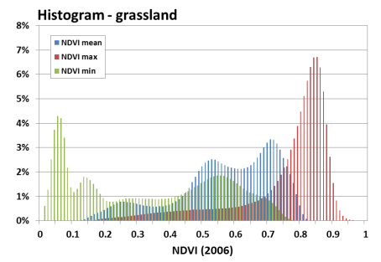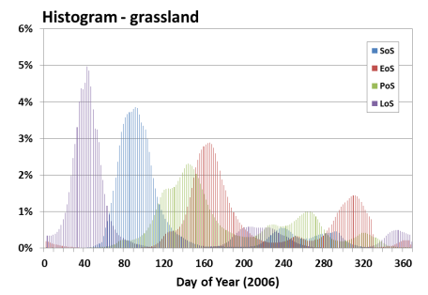
Figure 1 Histograms of the HANTS phenology 2006 for grassland
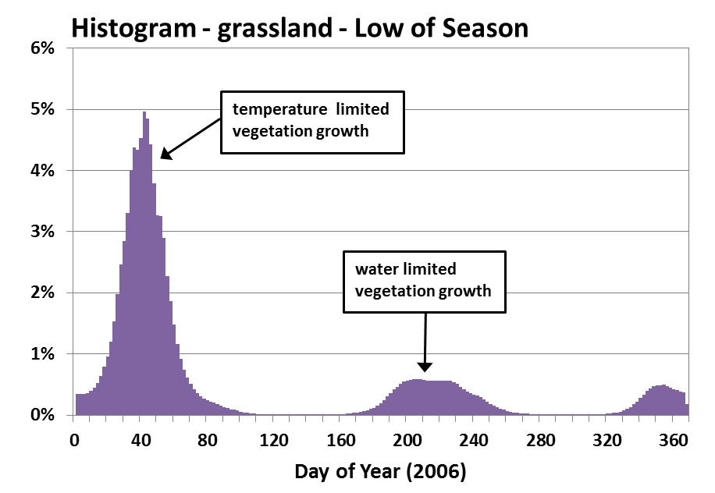
Figure 2 Histograms of HANTS phenology – Low of Season 2006 for grassland
Based on the two peaks in the histogram of LoS in figure 2, the dry grassland class is further limited to all grassland pixels having a LoS between day 150 and 290. This is occurring in the Mediterranean area and some parts of continental France. Statistics are run again on this grassland class and now the minimum NDVI is used to further define the dry grassland class.
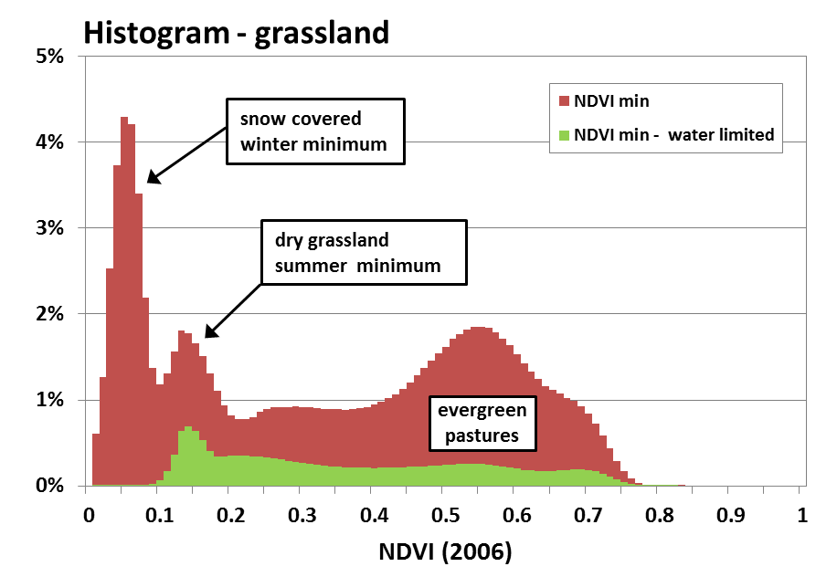
Figure 3 Histograms of HANTS phenology – Minimum NDVI 2006 for grassland and subclass water limited grassland
Figure 3 shows the histograms of the minimum NDVI of all grassland pixels and the water limited subclass (where 150<LoS<290, see Figure 2). The all grassland histogram has three peaks, the peak with the smallest NDVI values occur in winter time when pixels in Eastern and Northen Europe are covered with snow and ice. The second peak is slightly higher and has typical NDVI values for bare soil (NDVI between 0.1 and 0.2). What happened is that the vegetation in these pixels dies due to water stress, all photosynthetic activity stops and these pixels resemble bare soils NDVI values. The third peak is around minimum NDVI value of 0.55; these are the evergreen pastures in the Western part of Europe.
In the histogram of the water limited subclass the first peak disappeared. The second peak is still there and we define this peak as the dry grasslands. As there is no clear ending of this peak to the right, defining the threshold is a little arbitrary. With a trial and error method it is finally set at 0.25.
In short the following decision rules are used to define dry grassland:
- 150 < LoS < 290
- NDVI_min < 0.25
Critical remark 1: The NDVI_min threshold is set at 0.25; this threshold is defined arbitrary. If a validation dataset would be available the threshold could be defined properly on a scientific base.
Critical remark 2: A quick analysis of the resulting map made clear that in Turkey (Anatolia) there are large areas of grassland that have low NDVI values in summer due to water stress, but also in winter due to snow fall. In many parts the winter dip is lower than the summer dip so these areas have a LoS less than 150 and are wrongly excluded from being dry grassland. This can be solved by applying an additional set of decision rules for the Anatolian bio-geo region, not based on day number, but for example on mean NDVI (should be lower than threshold xxx).
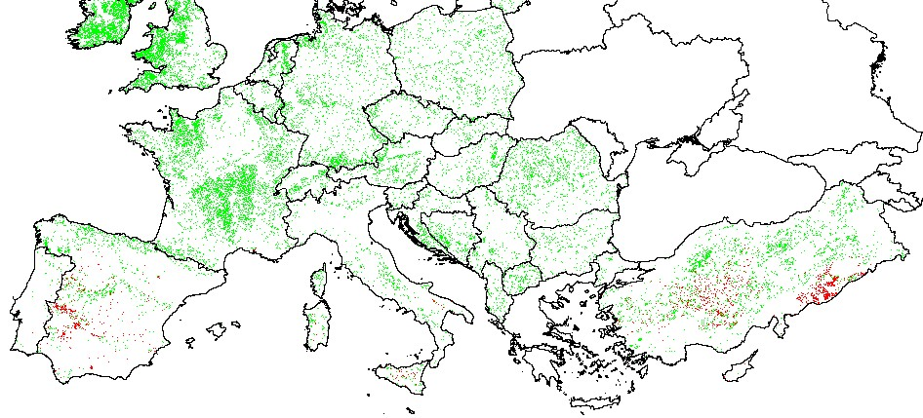
Figure 4 Map of dry grassland in Europe (red = dry grassland, green = other grassland)

G2 Broadleaved evergreen woodland

Definitions
The EUNIS definition of broad leaved evergreen woodland is: “Temperate forests dominated by broad-leaved sclerophyllous or lauriphyllous evergreen trees, or by palms. They are characteristic of the Mediterranean and warm-temperate humid zones.”
In plant phenological terms it could be rewritten as: Evergreen broadleaved forest has only a small seasonal difference as compared to deciduous broadleaved forest and occur only in the Mediterranean climate zone (in Europe).
In HANTS phenological terms it could be translated as: Evergreen broadleaved forest has a small difference between the maximum and minimum NDVI within a year and occur only in the Mediterranean climate zone (all other climate zones can be excluded from the analysis).

Method
The following steps are taken:
- Mask the HANTS phenology 2006 dataset with the CLC2006 land cover map, where all classes are masked except broadleaved forest
- Mask the HANTS phenology 2006 – broadleaved forest dataset with the given PotNatVeg climate map, where all classes are masked except the Mediterranean areas
- Run statistics on the HANTS phenology 2006 dataset of Mediterranean broadleaved forest and make histograms
- Analyse the histograms and draft decision rules
- Determine and finetune the threshold values for the decision rules
- Run the decision rules and create the evergreen broadleaved forest mask

Results
After the masking procedures in step 1 and 2 the histograms of all HANTS phenological parameters are made. Figure 5 shows them. On the left the mean, maximum and minimum NDVI histogram is shown, The mean NDVI shows two peaks; this is assumed to be coming from deciduous versus evergreen forest and is used as criteria for decision rule. On the right the histograms of day number of start, end, peak and low of the season is shown. Several peaks can be distinguished. However, analysis of the images shows that there is no relation between broadleaved forest type and peaks, so the information on day number is not used in this analysis.
Besides the mean NDVI (histogram in Figure 6) the seasonality is used to define the evergreen class. The seasonality is calculated as NDVI_max minus NDVI_min and the histogram is shown in Figure 7.
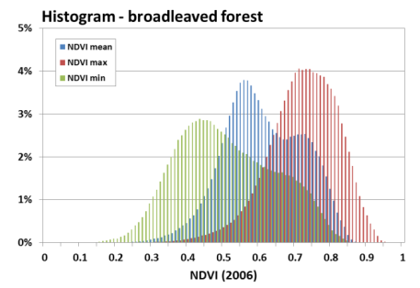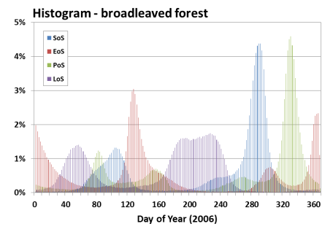
Figure 5 Histograms of the HANTS phenology 2006 for Mediterranean broadleaved forest
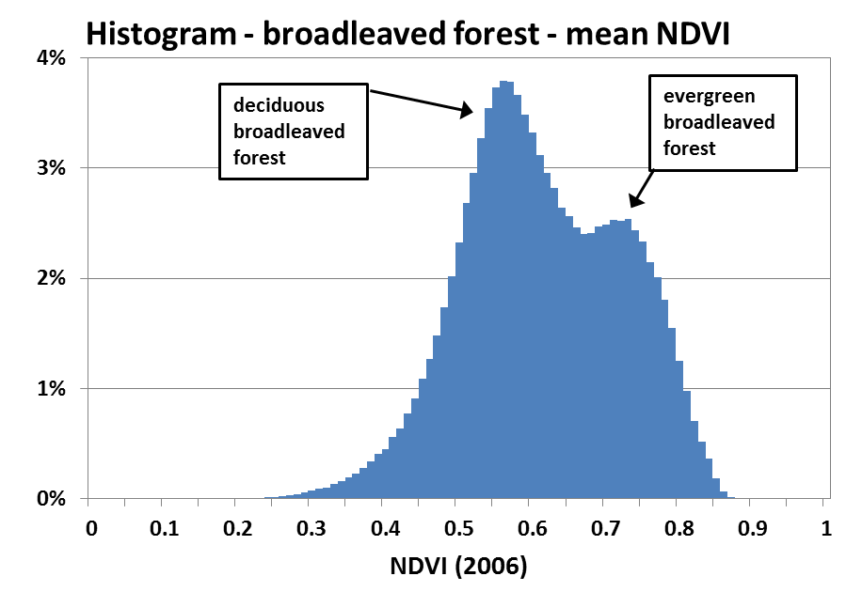
Figure 6 Histogram of HANTS phenology – Mean NDVI 2006 for Mediterranean broadleaved forest
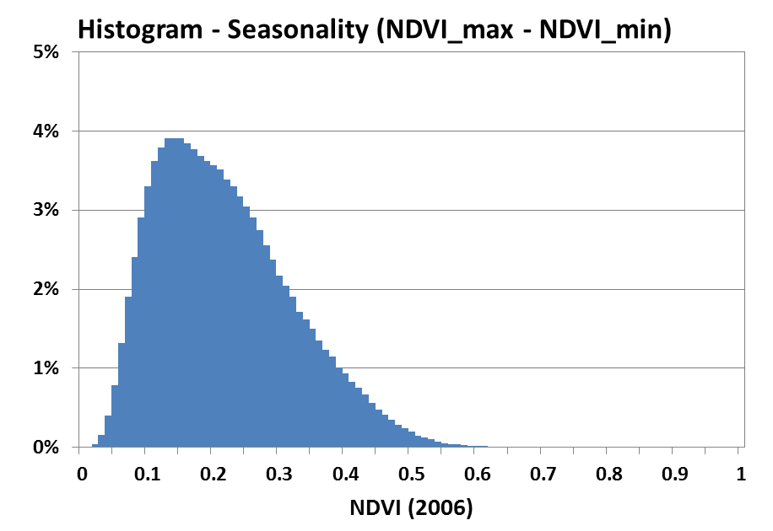
Figure 7 Histogram of HANTS phenology – Seasonality difference (NDVI_min – NDVI_max) for Mediterranean Broadleaved forest
The problem with the histograms in Figure 6 and 7 is that they have overlapping peaks. In figure 6 the two peaks are still visible, however in Figure 7 the difference between the first peak (at NDVI = 0.13) and the second peak, or better bending point in the curve (at NDVI = 0.23), is hardly visible. This can be explained by the fact that the transition from evergreen to deciduous forest is gradual and we are forced to set a threshold to separate both classes. A trial and error method gave the following set of decision rules:
- NDVI_mean > 0.63
- Seasonal difference: NDVI_max – NDVI_min < 0.22

Critical remark 1: The threshold values are not based on a scientific base. If a validation dataset would be available the threshold could be defined properly on a scientific base (perhaps the Andalucia forest dataset can be used for this, but I have to better understand the meaning of all classes in this dataset).
Critical remark2: Greece is missing in CLC2006. Should it be replaced by CLC 2000?
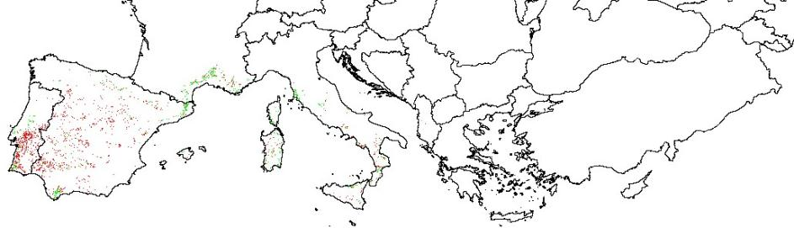
Figure 8 Map of Mediterranean evergreen broadleaved forest in Europe (green = Mediterranean evergreen broadleaved forest; red = Mediterranean deciduous broadleaved forest)

Mixed classes (CLC 242 and 243)

Background
The problem of the mixed CLC classes is that they have no direct crosswalk to any EUNIS class – therefore we have to split them up. Although there are relevant technical limitations of the MODIS HANTS dataset for such a task it is more important to demonstrate the method to contribute to the ecosystem mapping.

The objective of this case study is to derive arable land and grassland classes from the existing CLC2006 land cover classes 242 and 243 using HANTS dataset, which contains the following layers:
- Mean NDVI (NDVI value)
- Peak NDVI (NDVI value)
- Low NDVI (NDVI value)
- SOS - Start of Season (Day of the Year)
- EOS - End of Season (Day of the Year)
- POS - Peak of Season (Day of the Year)
- LOS - Low of Season (Day of the Year)

Definitions
The requirement is to “dismantle” the mixed CLC classes 242 (complex cultivation patterns) and 243 (Land principally occupied by agriculture, with significant areas of natural vegetation) into purely arable land and grassland classes by medium resolution MODIS time series processed into HANTS components.

A/ Initial assumptions:
1. Group: smoother NDVI dynamics -> grassland (E1, E2, E3)
2. Group: abrupt changes in NDVI -> arable land (I1)
This assumption is not fully valid as in case of intensively managed grasslands there are abrupt changes in the vegetation cover (EO signal) after grass cutting.

B/ Another assumption:
Crops grown on arable land have typically higher amplitude (from bare soil to maximum vegetation stage) than grasses. This assumption is partly linked to the first one.

Case study the Czech Republic
For Details refere to report 2013.

European scale mapping
The procedure tested on the AOI of the Czech Republic has been transferred to the continental level of Europe where CLC 2006 and HANTS were available.

Materials and Method
Input data:
- CORINE Land Cover 2006 (mask of mixed classes 242, 243; arable land and grassland classes for classification procedure training)
- HANTS dataset 2006 (phenology components and NDVI low, mean and peak)
- EEA Bio-geographical regions for stratification (Figure 5)
- NUTS2 regions for finer stratification

Algorithm:
- Maximum Likelihood Classifier approach
- Constrained to different bio-geographical regions (Alpine region in Scandinavia has been separated from Alps)

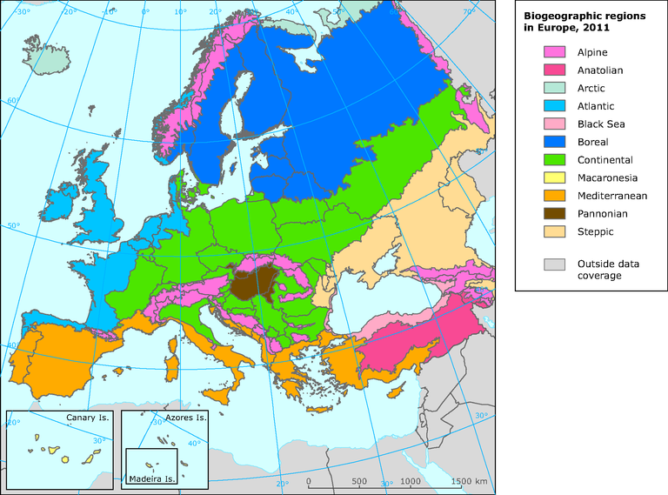
Figure 5: Bio-geographical regions of Europe used for stratification in the classification procedure

Results:
The results proved mostly the expected result. The spatial structure seems to be highly scattered. It is needed to say that have to have such structure. This proved the test with very high resolution LPIS (0.5 m product), Figure 3a. The accuracy of grassland class seems to be better than the arable land.
The classification result is provided in binary form (arable land / grassland), while the classification express how similar is the 250 m mixed pixel to arable land or grassland based on spectro-temporal HANTS signature of these two classes. In the procedure we attempt to classify 250 m pixel objects with large spetro-temporal mixing that are actually heterogeneous already in original 30 (20) m pixels of Landsat / SPOT / IRS during the visual interpretation.

Critical remark:
- Spatial resolution 250 m is a major limitation in the classification of the mixed classes

Conclusions:
- The results proved the expectations – limit of spatial resolution 250m;
- It provides demonstration of a method that can be applied to let the mixed classes reclassify into general LC elements as arable land and grassland, however, with high limit of accuracy due to spatial resolution. With this procedure we attempt to classify 250 m pixel objects that are actually heterogeneous in original 30 (20) m pixels during the visual interpretation!
- High accuracy of grassland classification (higher than expected) marks potential of the HANTS data set. However, it should be noted that there is high proportion of grass surfaces in the area of CLC classes 242 and 243, which improves the classification result;
- Certainly good results can be achieved with coming Sentinel-2 or even now with freely available and easily accessible Landsat-8; more investigation on Landsat 8 should be done;
- Other option, more straightforward, would be the use of GIO HR-layers for the task instead but then arable land layer would be missing.

Integrating other land cover data
The previously described datasets added additional thematic value for the discrimination of CORIEN Land cover classes. Within this section those datasets are described that provide an geometric added value as they improve the rather score CORIEN Land Cover mapping unit of 25 ha.

Forest layer
As the current GMES/Copernicus layer on forest types is still under production. The JRC forest layer from 2006 is a good alternative for this kind of integrated data. The JRC forest layer is produced with the original resolution of 25m pixels in the two categories:
- Coniferous forest
- Broadleaved forest

The original resolution is generalized to 100*100m with the following differentiation:
- Coniferous forest (coniferous percentage > 75%)
- Mixed forest (25% < coniferous percentage < 75%)
- Deciduous forest (coniferous percentage < 25%)

Forest type | Percentage coniferous | EUNIS Level 2 category
Coniferous | > 75% | G3 Coniferous woodland
Mixed | < 75% AND > 25% | G4 mixed deciduous and coniferous woodland
Deciduous | < 25 % | G1 broadleaved deciduous woodland

For the analysis only those forest pixels are analysed that are outside of the CORINE Land cover classes 311, 312 and 313.

From this dataset it is not possible to map the class G2 broadleaved evergreen woodland.

REMARK:
The class “water” is as well mapped in the JRC forest layer. But due to quality limitations at the current stage we have decided not to integrate this class in the final ecosystem mapping. One obvious error is the misclassification of water in urban areas. For example almost the whole city of Vienna is covered by “water” pixels. A more careful analysis of the quality would maybe leed to certain rules, in which areas the quality is sufficient to be integrated in the final ecosystem map and in which areas not.

OSM data
Open Street Map data provide more and more a reliable data source. What has started several years ago as spatially very localized project on digitizing roads has grown over the years to a world wide database of geographic features.
Due to the heterogeneity of the data only the following OSM data are extracted
- Main Roads (highways)
- Land use features with sealing percentage > 25%

OSM road integration
The major roads from Open Street Map are integrated as EUNIS class
- J4 Transport networks and other constructed hard-surfaced areas

OSM land use integration
The land use data in OSM represent polygon features with varying quality. Therefore the HRL imperviousness was used as an additional dataset to increase the reliability of this data.
Only pixels with a sealing degree > 25 % were used.
TYPE | ID_OSM | GRID_Code | EUNIS_L2 | EUNIS_L2
village_green | 10 | 53 | I2 | Cultivated areas of gardens and parks
park | 10 | 53 | I2 | Cultivated areas of gardens and parks
cemetery | 10 | 53 | I2 | Buildings of cities, towns and villages
retail | 21 | 54 | J1 | Buildings of cities, towns and villages
residential | 21 | 54 | J1 | Buildings of cities, towns and villages
industrial;retai | 21 | 54 | J1 | Buildings of cities, towns and villages
industrial | 21 | 54 | J1 | Buildings of cities, towns and villages
commercial | 21 | 54 | J1 | Buildings of cities, towns and villages
allotments | 22 | 55 | J2 | Low density buildings
industrial | 23 | 56 | J3 | Extractive industrial sites
railway | 24 | 57 | J4 | Transport networks and other constructed hard-surfaced areas
reservoir | 25 | 58 | J5 | Highly artificial man-made waters and associated structures

marine rules
to be completed by RAQUEL

Definition of Accuracy/Reliability
For a complex mapping approach as implemented with this ecosystem mapping it is necessary to document the reliability of the results. The resulting map is a mixture of various input data and depending on the input data the reliability/accuracy of the maps can be improved either geometrically or thematically.
These two parameters are considered as reliability measures. Each input data set is evaluated according to the information content. Some datasets provide an enhancement in geometrical terms and some in thematical terms.
The improvement potential and thus the reliability of each of the two parameters is estimated by expert-judgment for each input data source in a range of [1-10]. A very high reliability is coded with 10 points, whereas no improvement or not reliability is coded with 1 point.

Geometrical reliability
Although the mapping is conducted on a 100*100m pixel scale, the original minimum mapping unit (MMU) of CORINE Land Cover with 25 ha (=25 pixels) has to be considered. This means that every dataset that delivers information beyond this MMU improves the result geometrically.
The grade of the geometric reliability depends on the original resolution of the input data. Therefore it is necessary to know the MMU, scale, resolution and production logic of the input data. The high resolution layers e.g. provide a large reliability and thus improvement potential on a 100*100m grid, as they are produced in the original resolution of 20*20m. Whereas the soil maps do not provide an adequate improvement of reliability, as their original scale is 1:1 Mil. The lowest geometric reliability is attached to the Art. 17 distribution data, as they are only given in a 10*10 km2 raster (in addition we know that some countries e.g. France and Finland report even on larger entities).
Table: Some examples of geometric improvement are given in the table below:
reliability | Geometric  reliability | example 1 | example 2
1 | Very low | Art. 17 data (10*10 km)
2 |  | potNatVeg (1:1 Mil.) | ESDB-geology (1*1 km)
3 |  | soil wettness (1*1 km) | JRC riparian (1*1 km)
4 |  |  | WFD info as point
5 | intermediate | CLC 25 ha MMU as reference (500*500m)
6 |  | HANTS (250*250m) | WFD info as line
7 |  | alpine zone (DHM 30m+potNatVeg)
8 |  | OSM land use, HRL-layers (25m - Forest) | WFD info as polygon
9 |  | HRL-layers (20m)
10 | Very high | OSM-roads (line accuracy)

Thematic reliability

The thematic reliability describes to which grade the mapping results can be improved in thematic sense. This means it improves the differentiation between closely related classes.
The Article 17 distribution data are one good example. If they broadly cover all subtypes (on EUNIS level 3) of a specific ecosystem class, than they provide a very large reliability for the results, although their spatial resolution is quite coarse.
Table: Some examples of thematic improvement are given in the table below:
reliability | Thematic reliability | example 1 | example 2 | example 3
1 | very low | unclear CLC relation |  | 1:6 or 1:7 relation with CLC
2 |  | geology from ESBD |  | 1:4 or 1:5 relation with CLC
3 |  | soil wetness indicator | HRL sealing | 1:3 relation with CLC
4 |  | Art. 17 with minor coverage of all subtypes |  | 1:2 relation with CLC
5 | intermediate |  | JRC riparian | 1:1 relation with CLC
6 |  | Art. 17 with good coverage of all subtypes
7 |  | OSM land use | potNatVeg | HANTS-dry grasslands
8 |  | Art. 17 with complete coverage of all subtypes | alpine zone (better resolution - 20m, results only valid outside MED-area) | HANTS - evergreen broadleaved
9 |  |  | WFD info on naturalness
10 | very high | OSM-roads

Combined reliability
In case where more than one dataset are used within a rule, the maximum of the reliability/accuracy is taken as reference values, as the technical rules are always combined with AND. This means that the higher reliability of one datasets overrules the lower reliability of another dataset.
An exemption of the rule is the usage of Article 17 data, as this dat is regarded to be of high quality. Therefore the thematic quality of another dataset can not overrule the thematic quality of Article 17 data.
Example: 231 pastures are mapped to E7 sparsely wooded land under the following conditions:
- Forest cover percentage > 10% AND
- Potential natural vegetation = 9 (forest steppes) OR 10 (sclerophyllus forest)
Accuracy | Forest cover | Potential natural vegetation | Aggregated reliability (MAX)
Geometric | 8 | 2 | 8
Thematic | 6 | 7 | 7

For this specific combined rule the geometric reliability is 8 and the thematic reliability is 7, which is a substantial improvement to the pure usage of CORINE Land cover alone (geometric reliability 5 and thematic reliability in maximum 5).

Technical implementation of mapping rules
This chapter describes the technical implementation of the rules using EXCEL and ArcGIS Software.

Main input: crosswalk CLC-EUNIS
As starting point for the rules the crosswalk between CORINE Land Cover and the EUNIS classes developed by the ETC-BD is used. This crosswalk illustrates that the relation between CLC-classes and EUNIS classes is a m:n relation.
Over all groups the 1:n, m:1 and m:n relations are distributed as given in the following table:

Table: overview on types of relation in the cross-walk between CLC and EUNIS (e.g. a 1:3 relation between CLC and EUNIS means, that in 3 different EUNIS classes are linked to one CORINE class. And this 1:3 relationship is documented for 4 different CLC classes)
CLC: EUNIS Count  1:1 22  1:2 9  1:3 4  1:4 2  1:5 -  1:6 6  1:7 1  Sum of classes 44 | EUNIS : CLC Count  1:1 30  1:2 13  1:3 8  1:4 3  1:5 1  1:6 1  1:7 -  Sum of classes 56

The complete crosswalk between CLC and EUNIS is given in the Annex.

EUNIS habitat complexes (X)
A specific problem in the crosswalk are the habitat complexes (for a full list see Annex). They are still formulated as draft proposal in EUNIS, but they correspond to a range of CORINE classes. They have not been subjected to rigorous scrutiny to ensure consistency. Some of these complexes seem very promising to be mapped to CORINE Land cover classes e.g.:
For mapping only X01 Estuaries and X02 together with X03 coastal lagoons are mapped.
X0 | X01 | 2 | Estuaries | Downstream part of a river valley, subject to the tide and extending from the limit of brackish waters. River estuaries are coastal inlets where there is generally a substantial freshwater influence. The mixing of freshwater and sea water and the reduced current flows in the shelter of the estuary lead to deposition of fine sediments, often forming extensive intertidal sand and mud flats. In addition to herbs, they can also be colonised by shrubs creating thickets (e.g. [Tamarix] spp.). Where the tidal currents are faster than flood tides, most sediments deposit to form a delta at the mouth of the estuary. Baltic river mouths, considered as an estuary subtype, have brackish water and no tide, with helophytic wetland vegetation and luxurious aquatic vegetation in shallow water areas. Littoral and sublittoral habitat types typical of estuaries are included in A2 and A5, although many other habitat types including tidal rivers may occur in estuaries. Includes Transitional waters as defined by the Water Framework Directive.
X0 | X02 | 2 | Saline coastal lagoons | Lagoons are expanses of shallow coastal salt water, of varying salinity and water volume, wholly or partially separated from the sea by sand banks or shingle, or, less frequently, by rocks. Salinity may vary from brackish water to hypersalinity depending on rainfall, evaporation and through the addition of fresh seawater from storms, temporary flooding of the sea in winter or tidal exchange. With or without vegetation of seagrasses or charophytes. Habitat types typical of lagoons are included in A5, although many other habitat types may also occur in lagoons.
X0 | X03 | 2 | Brackish coastal lagoons | Lagoons are expanses of shallow coastal salt water, of varying salinity and water volume, wholly or partially separated from the sea by sand banks or shingle, or, less frequently, by rocks. Fully saline coastal lagoons are classified as X02.  Flads and gloes, considered a Baltic variety of lagoons, are small, usually shallow, more or less delimited water bodies still connected to the sea or cut off from the sea very recently by land upheaval. Characterised by well-developed reedbeds and luxuriant submerged vegetation and having several morphological and botanical development stages in the process whereby sea becomes land.  Mediterranean lagoons may host the [Ruppietum] community with halophytic vegetation, while at sites with a fresh water supply, plant communities of [Juncetum] and [Phragmitetum] can develop. [Sarcocornia perennis] and [Arthrocnemum macrostachyum] may occur here.

X0 | X06 | Crops shaded by trees | Crops, meadows or pastures developed under orchards or other cultivated tree plantations. The component habitat types may include elements of I1, E2.6 and FB.
X06 “crops shaded by trees” can preferably be linked to the CLC-class:
- 241 Annual crops associated with permanent crops

Refinement of m:n relations
All relations originating from the crosswalk between CORINE Land Cover an dEUNIS Level 2 were imported in EXCEL. The ambiguous relations were resolved using ancillary data as described in the previous chapters.
Each relations is captured in one EXCEL-line of one common spreadsheet. From these lines the relevant Python-Scripts were extracted and serve as interface to the ArcGIS implementation.
The Python-Scripts are available as ArcGIS module.
Beside the class-label according to the ecosystem class the following attributes are recorded for each pixel (except the marine ecosystems):
- Geometric reliability
- Thematic reliability
- Rule number
The geometric and thematic realiability are accuracy measures as explained in the previous chapter. The rule number improves the tracebility of the GIS procedure an relates each pixel with the corresponding rule in the EXCEL-file.

Results ecosystem type map

Version history
Table: Version numbers of ecosystem map
Version | Description | Date | Comments
V 1.1 | First draft map | 6. Oct. 2013 | Errors due to overlap of classes, aggregated CODE values not correct
V 1.3 | First quality checked results | 25. October 2013 | First wall-to-wall map, main errors removed;  Consultation meeting with Lubos Halada
V 1.4 | Inclusion of Greece | 3. December 2013 | Greece included with CLC 2000, refinement of thematic rules,
V 2.0 | Complete update | 31. July 2014 | New Art. 17 data form 2013 report included, WFD-data included, adapted rule set
Upcoming version
V 2.1 | Final map 2014 | Tentative date: 30. August 2014 | Integration of marine ecosystem types in one dataset

Map of ecosystem types
Dominating EUNIS Level 2 type within 100*100m Grid.
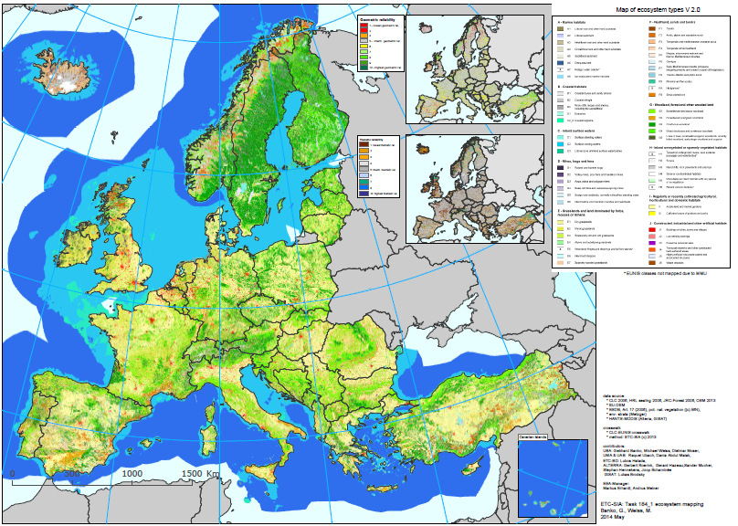

Statistic
Area coverage in [km2] for EUNIS Level 2 classes within EEA 39 countries. [TO BE INSERTED in FINAL REPORT, August 2014] For detailed country statistics see Annex.

Delivery Files
EiONET Forum:
http://forum.eionet.europa.eu/etc-sia-consortium/library/2014-subvention/184_1-ecosystem-mapping/milestones/draft-ecosystem-map-july-2014

Delivery contains:
- EXCEL
  - Includes complete rule set and look-up tables

- GIS-file
  - GRID-file 100*100m, ecosystem types (EUNIS L2)

EXCEL files
The rule set is delivered as MS EXCEL file with the spreadsheets defined in the table below.
File: ES_mapping_rules_v2_0_export.xlsx

Table: Definition of spreadsheets for rule sets stored in EXCEL.
spreadsheet | description
Readme | Documentation
EUNIS_to_CLC_2 | Original crosswalk CLC--> EUNIS; © ETC-BD, extraction of EUNIS Level 2 classes
ES_Codes | List of ecosystem types according to MEAS L1+L2, explained by EUNIS L2; including GRID-Code for GIS data
Rules_v2_0 | rules to refine the m:n relation between CLC and EUNIS, including rule ID; Version of rule set is attached to spread sheet name
Grids | additional data grids necessary for rule implementation
potNatVeg_Codes | Aggregation of potential natural vegetation zones that are useful for rule definition and implementation
Annex_I | relation between EUNIS and Annex I habitats (habitat directive), used as Input for Art. 17 data selection
Reliability | Accuracy/reliability definitions for input data (geometric and thematic reliability)
Rel_HRL | high resolution databases - definition of reliability and rule ID
HRL_rules | Rules used for integrated land cover information; mapping of OSM-data and HRL sealing towards EUNIS classes L2
LUT_CLC | look up table for CORINE Land Cover
EUNIS_CLC | Final overview of geometric and thematic mapping rules used for the ecosystem type map

GRID-files
The output contains four different grid files.
- One grid files holds the ecosystem type values, and the
- two grid files contain information on the quality (geometric and thematic) and
- one grid file contains information on the specific rule that lead to the final ecosystem type.
The exact definition is given in the table below.

Table: Acronyms used in GIS file naming conventions
Acronym | Name | Description
…c | Class type | Ecosystem types (classes) with GRID-code value according to typology
…g | Geometry | Geometrical reliability between 1 (lowest) and 10 (highest)
…t | Thematic | Thematic reliability between 1 (lowest) and 10 (highest)
…r | rule | Identification of rule and datasets used for ecosystem class creation

Naming of GRID-files:
- es_all_c_v2_0
  - es ecosystem types
  - all combined dataset based on CLC-approach AND other land cover data (OSM, HRL)
  - c type of grid according to table above (c..class)
  - v2_0 Version of dataset (e.g. 2.0)

Python Scripts
The python scripts necessary for conducting the calculation are copied to the EiONET Forum.

Appendix

Crosswalk MAES-EUNIS-CLC
MEAS_L1 | MAES_L2 | EUNIS L1 | EUNIS code | EUNIS name | CLC | CLC_Name | additionaldata | Rule | remark
Marine | Marine | A Marine habitats | A1 | Littoral rock and other hard substrata | 423 | Intertidal flats |  | 1:1
 |  |  | A3_4 | Infralittoral (A3) and circalittoral (A4) rock and other hard substrata | 523 | Sea and ocean | altitudinal zone | see marine rules
 |  |  | A5 | Sublittoral sediment | 523 | Sea and ocean | depth zones | see marine rules
 |  |  | A6 | Deep-sea bed | 523 | Sea and ocean | substrate | see marine rules
 |  |  | A7 | Pelagic water column | 523 | Sea and ocean | salinity | see marine rules
 |  |  | A8 | Ice-associated marine habitats | 523 | Sea and ocean | wettness | see marine rules
 |  |  | X1 | Estuaries | 522 | Estuaries |  | 1:1
 |  |  | X2_3 | Sublittoral sediment | 521 | Coastal Lagoons |  | 1:1
Coastal | Lagoons, coastal wetlands and estuaries | B Coastal habitats | B1 | Coastal dunes and sandy shores | 231 | Pastures | potnatVeg | coastal zone (potnatVeg)
 |  |  |  |  | 323 | Sclerophyllous vegetation | coastline | distance to coast < 1000m
 |  |  |  |  | 331 | Beaches, dunes, and sand plains | Art. 17 | Art.17=B1 AND Vegetation of coastal sand dunes, sea shores and Halophytic vegetation (potnatVeg)
 |  |  | B2 | Coastal shingle | 331 | Beaches, dunes, and sand plains | Art. 17 | Art.17=B2
 |  |  | B3 | Littoral rock and other hard substrata | 332 | Bare rock | Art. 17 | Art.17=B3 AND distance to coast <1000m
 |  |  |  |  | 332 | Bare rock |  | rocks are adjacent to sea AND distance to coast <1000m
Feshwater | Rivers and Lakes | C Inland surface waters | C1 | Surface standing waters | 512 | Water bodies |  | C1, if no other rule applies
 |  |  | C2 | Surface running waters | 511 | Water courses |  | C2, if no other rule applies
 |  |  | C3 | Littoral zone of inland surface waterbodies | 331 | Beaches, dunes, and sand plains | riparian zone | within riparian area (10% threshold) - (priority rule 3)
 |  |  | C3 | Littoral zone of inland surface waterbodies | 411 | Inland marshes |  | adjacent to a lake (priority 7)
Terrestrial | Wetlands | D Mires, bogs and fens | D1 | Raised and blanket bogs | 412 | Peatbogs | Art. 17 | Art.17=D1 (priority 2)
 |  |  |  |  | 412 | Peatbogs |  | D1, if no other rule applies (priority 4)
 |  |  | D2 | Valley mires, poor fens and transition mires | 411 | Inland marshes | Art. 17 | Art.17=D2 and Art.17 = not D4 (priority 3)
 |  |  |  |  | 411 | Inland marshes | Art. 17 | Art.17=D2 (priority 6)
 |  |  | D3 | Aapa, palsa and polygon mires | 412 | Peatbogs | Art. 17 | Art.17=D3 (priority 1)
 |  |  |  |  | 412 | Peatbogs | elevation zone | in alpine, boreal and atlantic zone (potnatVeg) (priority 3)
 |  |  | D4 | Base-rich fens and calcareous spring mires | 411 | Inland marshes | Art. 17 | Art.17=D4 and Art.17 = not D2 (priority 4)
 |  |  |  |  | 411 | Inland marshes | Art. 17 | Art.17 = (D2 AND D4), AND soil=calcareous (priority 5)
 |  |  | D5 | Sedge and reedbeds, normally without free-standing water | 411 | Inland marshes | Art. 17 | Art.17=D5 (not very representative for D5) (priority 2)
 |  |  |  |  | 411 | Inland marshes |  | D5, if no other rule applies
 |  |  | D6 | Inland saline and brackish marshes and reedbeds | 411 | Inland marshes | Art. 17 | Art.17=D6 (only very small areas) (priority 1)
 | Grassland | E Grasslands and land dominated by forbs, mosses or lichens | E1 | Dry grasslands | 231 | Pastures | HANTS | HANTS=dry (priority 5)
 |  |  |  |  | 321 | Natural grassland | HANTS | HANTS=dry (priority 3)
 |  |  | E2 | Mesic grasslands | 231 | Pastures |  | E2, if no other rule applies
 |  |  |  |  | 242 | Complex cultivation patterns | HANTS | HANTS = grassland
 |  |  |  |  | 243 | Land principally occupied by agriculture, with significant areas of natural vegetation | HANTS | HANTS = grassland
 |  |  |  |  | 321 | Natural grassland |  | E2, if no other rule applies
 |  |  | E3 | Seasonally wet and wet grasslands | 231 | Pastures | soil | wet soils (priority 4)
 |  |  |  |  | 321 | Natural grassland | soil | wet soils (priority 2)
 |  |  | E4 | Alpine and subalpine grasslands | 231 | Pastures | elevation zone | subalpine zone (priority 1)
 |  |  |  |  | 321 | Natural grassland | elevation zone | subalpine zone (priority 1)
 |  |  | E6 | Inland salt steppes | 421 | Salt marshes |  | 1:1
 |  |  | E7 | Sparsely wooded grasslands | 231 | Pastures | potnatVeg | forest steps and mediterranean scrubs (potnatVeg) AND forest cover >10% (priority 3)
 |  |  |  |  | 244 | Agro-forestry areas |  | 1:1
 | Heathland and shrub | F Heathland, scrub and tundra | F1 | Tundra | 333 | Sparsely vegetated areas | potnatVeg | Tundra region (potnatVeg) (priority 2)
 |  |  | F2 | Arctic, alpine and subalpine scrub | 322 | Moors and heathland | elevation zone | subalpine zone (priority 1)
 |  |  |  |  | 333 | Sparsely vegetated areas | elevation zone | subalpine zone OR in Arctic shrub tundras (potnatVeg) (priority 1)
 |  |  | F3 | Temperate and mediterranean-montane scrub | 322 | Moors and heathland | Art. 17 | Art.17=F3 (priority 3)
 |  |  |  |  | 322 | Moors and heathland |  | F3, if no other rule applies
 |  |  | F4 | Temperate shrub heathland | 322 | Moors and heathland | Art. 17 | Art.17=F4 AND potNatVeg="atlantic dwarf shrub heat" AND Soil = acid (priority 4)
 |  |  | F5 | Maquis, arborescent matorral and thermo-Mediterranean brushes | 323 | Sclerophyllous vegetation | Art. 17 | Art.17=F5 in mediterranean scler. forest and shrub (potnatVeg) (priority 5)
 |  |  |  |  | 323 | Sclerophyllous vegetation |  | F5, if not other rule applies
 |  |  | F6 | Garrigue | 323 | Sclerophyllous vegetation | Art. 17 | Art.17=F6 in mediterranean scler. forest and shrub (potnatVeg) (priority 3)
 |  |  | F7 | Spiny Mediterranean heaths (phrygana, hedgehog-heaths and related coastal cliff vegetation) | 323 | Sclerophyllous vegetation | Art. 17 | Art.17=F7 in mediterranean scler. forest and shrub (potnatVeg) (priority 4)
 |  |  | F8 | Thermo-Atlantic xerophytic scrub | 323 | Sclerophyllous vegetation | potnatVeg | in Madeira/Canarian Islands
 |  |  | F9 | Riverine and fen scrubs | 322 | Moors and heathland | riparian zone | close to riparian zone (JRC) (priority 2)
 |  |  | FA | Hedgerows |  |  |  |  | too small
 |  |  | FB | Shrub plantations | 221 | Vineyards |  | 1:1
 |  |  |  |  | 222 | Fruit trees and berry plantations |  | 1:1
 | Woodland and forest | G Woodland, forest and other wooded land | G1 | Broadleaved deciduous woodland | HRL forest | JRC_forest: deciduous | HRL forest |  | forest layer applied only outside CLC-forest
 |  |  |  |  | 311 | Broad-leaved forest |  | if not G2, then G1 (priority 2)
 |  |  | G2 | Broadleaved evergreen woodland | 223 | Olive groves |  | 1:1
 |  |  |  |  | 311 | Broad-leaved forest | HANTS | evergreen zone (potNatVeg), when HANTS=evergreen (priority 1)
 |  |  | G3 | Coniferous woodland | HRL forest | JRC_forest: coniferous | HRL forest |  | forest layer applied only outside CLC-forest
 |  |  |  |  | 312 | Coniferous forest |  | 1:1
 |  |  | G4 | Mixed deciduous and coniferous woodland | 313 | Mixed forest |  | 1:1
 |  |  | G5 | Lines of trees, small anthropogenic woodlands, recently felled woodland, early-stage woodland and coppice | 324 | Transitional woodland shrub |  | 1:1
 | Sparsely or unvegetated land | H Inland unvegetated or sparsely vegetated habitats | H1 | Terrestrial underground caves, cave systems, passages and waterbodies |  |  |  |  | not applicable
 |  |  | H2 | Screes | 331 | Beaches, dunes, and sand plains |  | H2, if no other rule applies
 |  |  | H3 | Inland cliffs, rock pavements and outcrops | 332 | Bare rock |  | H3, if no other rule on CLC 332 applies
 |  |  |  |  | 333 | Sparsely vegetated areas | DEM | in steep terrain (slope >15°) (priority 3)
 |  |  | H4 | Snow or ice-dominated habitats | 335 | Glaciers and perpetual snow |  | 1:1
 |  |  | H5 | Miscellaneous inland habitats with very sparse or no vegetation | 333 | Sparsely vegetated areas |  | H5, if no other rule on CLC 333 applies (priority 4)
 |  |  |  |  | 334 | Burnt areas |  | 1:1
 |  |  | H6 | Recent volcanic features |  |  |  |  | not applicable
 | Cropland | I Regularly or recently cultivated agricultural, horticultural and domestic habitats | I1 | Arable land and market gardens | 211 | Non-irrigated arable land |  | 1:1
 |  |  |  |  | 212 | Permanently irrigated land |  | 1:1
 |  |  |  |  | 213 | Rice fields |  | 1:1
 |  |  |  |  | 241 | Annual crops associated with permanent crops |  | 1:1
 |  |  |  |  | 242 | Complex cultivation patterns | HANTS | I1, when HANTS=agriculture
 |  |  |  |  | 243 | Land principally occupied by agriculture, with significant areas of natural vegetation | HANTS | I1, when HANTS=agriculture
 |  |  | I2 | Cultivated areas of gardens and parks | 141 | Green urban areas |  | 1:1
 |  |  |  |  | 142 | Sport and leisure facilities |  | 1:1
 | Urban | J Constructed, industrial and other artificial habitats | J1 | Buildings of cities, towns and villages | OSM land use | OSM-land use: retail, residential, industiral, commercial; |  |  | OSM land use only outside CLC-urban and with sealing > 30%
 |  |  |  |  | HRL sealing | HRL-sealing (51-100) |  |  | sealing only outside CLC-urban
 |  |  |  |  | 111 | Continuous urban fabric |  | 1:1
 |  |  |  |  | 112 | Discontinuous urban fabric | HRL sealing | HRL_sealing >= 30
 |  |  |  |  | 121 | Industrial or commercial units | HRL sealing | HRL_sealing >= 50
 |  |  | J2 | Low density buildings | OSM land use | OSM-land use: village_green, park, cemetery, allotments; |  |  | OSM land use only outside CLC-urban and with sealing > 30%
 |  |  |  |  | HRL sealing | HRL-sealing (25-50) |  |  | sealing only outside CLC-urban
 |  |  |  |  | 112 | Discontinuous urban fabric | HRL sealing | HRL_sealing < 30
 |  |  |  |  | 121 | Industrial or commercial units | HRL sealing | HRL_sealing < 50
 |  |  |  |  | 133 | Construction sites |  | 1:1
 |  |  | J3 | Extractive industrial sites | 131 | Mineral extraction sites |  | 1:1
 |  |  | J4 | Transport networks and other constructed hard-surfaced areas | OSM roads | OSM roads: motorways
 |  |  |  |  | OSM land use | OSM-land use: railway |  |  | OSM land use only outside CLC-urban and with sealing > 30%
 |  |  |  |  | 122 | Road and rail networks and associated land |  | 1:1
 |  |  |  |  | 123 | Port areas |  | 1:1
 |  |  |  |  | 124 | Airports |  | 1:1
 |  |  | J5 | Highly artificial man-made waters and associated structures | OSM land use | OSM-land use: reservoir |  |  | OSM land use only outside CLC-urban and with sealing > 30%
 |  |  |  |  | 422 | Salines |  | 1:1
 |  |  |  |  | 511 | Water courses | WFD | J5, if WFD = artificial (priority 1)
 |  |  |  |  | 512 | Water bodies | WFD | J5, if WFD = artificial (priority 1)
 |  |  | J6 | Waste deposits | 132 | Dump sites |  | 1:1

Typology of ecosystems (EUNIS Level 2) and GRID Code
Level 1 types | EUNIS_L2_ID | ID_Grid_L2 | EUNIS_name
A Marine habitats | A1 | 1 | Littoral rock and other hard substrata
 | A2 | 2 | Littoral sediment
 | A3 | 3 | Infralittoral rock and other hard substrata
 | A4 | 4 | Circalittoral rock and other hard substrata
 | A5 | 5 | Sublittoral sediment
 | A6 | 6 | Deep-sea bed
 | A7 | 7 | Pelagic water column
 | A8 | 8 | Ice-associated marine habitats
Transition zone | X1 | 9 | Estuaries
 | X2_3 | 10 | Coastal lagoons
B Coastal habitats | B1 | 11 | Coastal dunes and sandy shores
 | B2 | 12 | Coastal shingle
 | B3 | 13 | Rock cliffs, ledges and shores, including the supralittoral
C Inland surface waters | C1 | 14 | Surface standing waters
 | C2 | 15 | Surface running waters
 | C3 | 16 | Littoral zone of inland surface waterbodies
D Mires, bogs and fens | D1 | 17 | Raised and blanket bogs
 | D2 | 18 | Valley mires, poor fens and transition mires
 | D3 | 19 | Aapa, palsa and polygon mires
 | D4 | 20 | Base-rich fens and calcareous spring mires
 | D5 | 21 | Sedge and reedbeds, normally without free-standing water
 | D6 | 22 | Inland saline and brackish marshes and reedbeds
E Grasslands and land dominated by forbs, mosses or lichens | E1 | 23 | Dry grasslands
 | E2 | 24 | Mesic grasslands
 | E3 | 25 | Seasonally wet and wet grasslands
 | E4 | 26 | Alpine and subalpine grasslands
 | E5 | 27 | Woodland fringes and clearings and tall forb stands
 | E6 | 28 | Inland salt steppes
 | E7 | 29 | Sparsely wooded grasslands
F Heathland, scrub and tundra | F1 | 30 | Tundra
 | F2 | 31 | Arctic, alpine and subalpine scrub
 | F3 | 32 | Temperate and mediterranean-montane scrub
 | F4 | 33 | Temperate shrub heathland
 | F5 | 34 | Maquis, arborescent matorral and thermo-Mediterranean brushes
 | F6 | 35 | Garrigue
 | F7 | 36 | Spiny Mediterranean heaths (phrygana, hedgehog-heaths and related coastal cliff vegetation)
 | F8 | 37 | Thermo-Atlantic xerophytic scrub
 | F9 | 38 | Riverine and fen scrubs
 | FA | 39 | Hedgerows
 | FB | 40 | Shrub plantations
G Woodland, forest and other wooded land | G1 | 41 | Broadleaved deciduous woodland
 | G2 | 42 | Broadleaved evergreen woodland
 | G3 | 43 | Coniferous woodland
 | G4 | 44 | Mixed deciduous and coniferous woodland
 | G5 | 45 | Lines of trees, small anthropogenic woodlands, recently felled woodland, early-stage woodland and coppice
H Inland unvegetated or sparsely vegetated habitats | H1 | 46 | Terrestrial underground caves, cave systems, passages and waterbodies
 | H2 | 47 | Screes
 | H3 | 48 | Inland cliffs, rock pavements and outcrops
 | H4 | 49 | Snow or ice-dominated habitats
 | H5 | 50 | Miscellaneous inland habitats with very sparse or no vegetation
 | H6 | 51 | Recent volcanic features
I Regularly or recently cultivated agricultural, horticultural and domestic habitats | I1 | 52 | Arable land and market gardens
 | I2 | 53 | Cultivated areas of gardens and parks
J Constructed, industrial and other artificial habitats | J1 | 54 | Buildings of cities, towns and villages
 | J2 | 55 | Low density buildings
 | J3 | 56 | Extractive industrial sites
 | J4 | 57 | Transport networks and other constructed hard-surfaced areas
 | J5 | 58 | Highly artificial man-made waters and associated structures
 | J6 | 59 | Waste deposits

EUNIS Level 2 class descriptions
Group 2 | EUNIS name | Description
A1 | Littoral rock and other hard substrata | Littoral rock includes habitats of bedrock, boulders and cobbles which occur in the intertidal zone (the area of the shore between high and low tides) and the splash zone. The upper limit is marked by the top of the lichen zone and the lower limit by the top of the laminarian kelp zone. There are many physical variables affecting rocky shore communities - wave exposure, salinity, temperature and the diurnal emersion and immersion of the shore. Wave exposure is most commonly used to characterise littoral rock, from 'extremely exposed' on the open coast to 'extremely sheltered' in enclosed inlets. Exposed shores tend to support faunal-dominated communities of barnacles and mussels and some robust seaweeds. Sheltered shores are most notable for their dense cover of fucoid seaweeds, with distinctive zones occurring down the shore. In between these extremes of wave exposure, on moderately exposed shores, mosaics of seaweeds and barnacles are more typical.
A2 | Littoral sediment | Littoral sediment includes habitats of shingle (mobile cobbles and pebbles), gravel, sand and mud or any combination of these which occur in the intertidal zone. Littoral sediment is defined further using descriptions of particle sizes - mainly gravel (16-4 mm), coarse sand (4-1 mm), medium sand (1-0.25 mm), fine sand (0.25-0.063 mm) and mud (less than 0.063 mm) and various admixtures of these (and coarser) grades - muddy sand, sandy mud and mixed sediment (cobbles, gravel, sand and mud together). Littoral sediments support communities tolerant to some degree of drainage at low tide and often subject to variation in air temperature and reduced salinity in estuarine situations. Very coarse sediments tend to support few macrofaunal species because these sediments tend to be mobile and subject to a high degree of drying when exposed at low tide. Finer sediments tend to be more stable and retain some water between high tides, and therefore support a greater diversity of species. Medium and fine sand shores usually support a range of oligochaetes, polychaetes, and burrowing crustaceans, and even more stable muddy sand shores also support a range of bivalves. Very fine and cohesive sediment (mud) tends to have a lower species diversity, because oxygen cannot penetrate far below the sediment surface. A black, anoxic layer of sediment develops under these circumstances, which may extend to the sediment surface and in which few species can survive. Some intertidal sediments are dominated by angiosperms, e.g. eelgrass ([Zostera noltii]) beds on the mid and upper shore of muddy sand flats, or saltmarshes which develop on the extreme upper shore of sheltered fine sediment flats.  Situation: Littoral sediments are found across the entire intertidal zone, including the strandline. Sediment biotopes can extend further landwards (dune systems, marshes) and further seawards (sublittoral sediments). Sediment shores are generally found along relatively more sheltered stretches of coast compared to rocky shores. Muddy shores or muddy sand shores occur mainly in very sheltered inlets and along estuaries, where wave exposure is low enough to allow fine sediments to settle. Sandy shores and coarser sediment (gravel, pebbles, cobbles) shores are found in areas subject to higher wave exposures.  Temporal variation: Littoral sediment environments can change markedly over seasonal cycles, with sediment being eroded during winter storms and accreted during calmer summer months. The particle size structure of the sediment may change from finer to coarser during winter months, as finer sediment gets resuspended in seasonal exposed conditions. This may affect the sediment infauna, with some species only present in summer when sediments are more stable. These changes are most likely to affect sandy shores on relatively open shores. Sheltered muddy shores are likely to be more stable throughout the year, but may have a seasonal cover of green seaweeds during the summer period, particularly in nutrient enriched areas or where there is freshwater input.
A3 | Infralittoral rock and other hard substrata | Infralittoral rock includes habitats of bedrock, boulders and cobbles which occur in the shallow subtidal zone and typically support seaweed communities. The upper limit is marked by the top of the kelp zone whilst the lower limit is marked by the lower limit of kelp growth or the lower limit of dense seaweed growth. Infralittoral rock typically has an upper zone of dense kelp (forest) and a lower zone of sparse kelp (park), both with an understorey of erect seaweeds. In exposed conditions the kelp is [Laminaria hyperborea] whilst in more sheltered habitats it is usually [Laminaria saccharina]; other kelp species may dominate under certain conditions. On the extreme lower shore and in the very shallow subtidal (sublittoral fringe) there is usually a narrow band of dabberlocks [Alaria esculenta] (exposed coasts) or the kelps [Laminaria digitata] (moderately exposed) or [L. saccharina] (very sheltered). Areas of mixed ground, lacking stable rock, may lack kelps but support seaweed communities. In estuaries and other turbid-water areas the shallow subtidal may be dominated by animal communities, with only poorly developed seaweed communities.
A4 | Circalittoral rock and other hard substrata | Circalittoral rock is characterised by animal dominated communities (a departure from the algae dominated communities in the infralittoral zone). The circalittoral zone can itself be split into two sub-zones; upper circalittoral (foliose red algae present but not dominant) and lower circalittoral (foliose red algae absent). The depth at which the circalittoral zone begins is directly dependent on the intensity of light reaching the seabed; in highly turbid conditions, the circalittoral zone may begin just below water level at mean low water springs (MLWS). The biotopes identified in the field can be broadly assigned to one of three energy level categories: high, moderate and low energy circalittoral rock (used to define the habitat complex level). The character of the fauna varies enormously and is affected mainly by wave action, tidal stream strength, salinity, turbidity, the degree of scouring and rock topography. It is typical for the community not to be dominated by single species, as is common in shore and infralittoral habitats, but rather comprise a mosaic of species. This, coupled with the range of influencing factors, makes circalittoral rock a difficult area to satisfactorily classify; particular care should therefore be taken in matching species and habitat data to the classification.
A5 | Sublittoral sediment | Sediment habitats in the sublittoral near shore zone (i.e. covering the infralittoral and circalittoral zones), typically extending from the extreme lower shore down to the edge of the bathyal zone (200 m). Sediment ranges from boulders and cobbles, through pebbles and shingle, coarse sands, sands, fine sands, muds, and mixed sediments. Those communities found in or on sediment are described within this broad habitat type.
A6 | Deep-sea bed | The sea bed beyond the continental shelf break. The shelf break occurs at variable depth, but is generally over 200 m. The upper limit of the deep-sea zone is marked by the edge of the shelf. Includes areas of the Mediterranean Sea which are deeper than 200 m but not of the Baltic Sea which is a shelf sea. Excludes caves in the deep sea which are classified in A4.71 irrespective of depth.
A7 | Pelagic water column | The water column of shallow or deep sea, or enclosed coastal waters. Note that because of the strong temporal nature of the pelagic environment, the water column at a given location will be classified differently at different times of the year.
A8 | Ice-associated marine habitats | Sea ice, icebergs and other ice-associated marine habitats.
B1 | Coastal dunes and sandy shores | Sand-covered shorelines of the oceans, their connected seas and associated coastal lagoons, fashioned by the action of wind or waves. They include gently sloping beaches and beach-ridges, formed by sands brought by waves, longshore drift and storm waves, as well as dunes, formed by aeolian deposits, though sometimes re-fashioned by waves.
B2 | Coastal shingle | Beaches of the oceans, of their connected seas and of their associated coastal lagoons, covered by pebbles, or sometimes boulders, usually formed by wave action.
B3 | Rock cliffs, ledges and shores, including the supralittoral | Rock exposures adjacent to the oceans, their connected seas and associated coastal lagoons, or separated from them by a narrow shoreline. The faces, ledges and caves of sea-cliffs and the expanses of rocky shore are important as reproduction, resting and feeding sites for seabirds, sea-mammals and a few groups of terrestrial birds. Sea-cliffs may also harbour highly distinctive, specialised salt-tolerant vegetation with associated terrestrial fauna.
C1 | Surface standing waters | Lakes, ponds and pools of natural origin containing fresh (i.e. nonsaline), brackish or salt water. Manmade freshwater bodies, including artificially created lakes, reservoirs and canals, provided that they contain seminatural aquatic communities.
C2 | Surface running waters | Running waters, including springs, streams and temporary water courses.
C3 | Littoral zone of inland surface waterbodies | Reedbeds and other water-fringing vegetation by lakes, rivers and streams; exposed bottoms of dried up rivers and lakes; rocks, gravel, sand and mud beside or in the bed of rivers and lakes.
D1 | Raised and blanket bogs | Peatlands formed by ombrotrophic acid peat, which is (or was while actively growing) capable of growth fed by rainfall rather than by the inflow of water from higher ground in the vicinity.
D2 | Valley mires, poor fens and transition mires | Weakly to strongly acid peatlands, flushes and vegetated rafts formed in situations where they receive water from the surrounding landscape or are intermediate between land and water. Included are quaking bogs and vegetated non-calcareous springs. Excluded are calcareous fens (D4), and reedbeds (C3, D5).
D3 | Aapa, palsa and polygon mires | Patterned mire complexes of the arctic, subarctic and northern boreal zones.
D4 | Base-rich fens and calcareous spring mires | Peatlands, flushes and vegetated springs with calcareous or eutrophic ground water, within river valleys, alluvial plains, or on hillsides. As in poor fens, the water level is at or near the surface of the substratum and peat formation depends on a permanently high watertable. Excluded are reedbeds (C3, D5).
D5 | Sedge and reedbeds, normally without free-standing water | Sedge and reedbeds forming terrestrial mire habitats, not closely associated with open water. Excluded are reedbeds and sedges where they form emergent or fringing vegetation beside water bodies (C3.2).
D6 | Inland saline and brackish marshes and reedbeds | Saline wetlands, with closed or open vegetation, which are the non-coastal analogue of coastal saltmarshes and saline reedbeds (A2.5). Drier saline habitats are classified as inland salt steppe (E6) or saline scrubland (F6.8).
E1 | Dry grasslands | Well-drained or dry lands dominated by grass or herbs, mostly not fertilized and with low productivity. Included are [Artemisia] steppes. Excluded are dry mediterranean lands with shrubs of other genera where the shrub cover exceeds 10%; these are listed as garrigue (F6).
E2 | Mesic grasslands | Lowland and montane mesotrophic and eutrophic pastures and hay meadows of the boreal, nemoral, warm-temperate humid and mediterranean zones. They are generally more fertile than dry grasslands (E1), and include sports fields and agriculturally improved and reseeded pastures.
E3 | Seasonally wet and wet grasslands | Unimproved or lightly improved wet meadows and tall herb communities of the boreal, nemoral, warm-temperate humid, steppic and mediterranean zones.
E4 | Alpine and subalpine grasslands | Primary and secondary grass- or sedge- dominated formations of the alpine and subalpine levels of boreal, nemoral, mediterranean, warm-temperate humid and Anatolian mountains.
E5 | Woodland fringes and clearings and tall forb stands | Stands of tall herbs or ferns, occuring on disused urban or agricultural land, by watercourses, at the edge of woods, or invading pastures. Stands of shorter herbs forming a distinct zone (seam) at the edge of woods.
E6 | Inland salt steppes | Saline land with dominant salt-tolerant grasses and herbs. Excludes saline scrubland, listed under F6.8 xero-halophile scrubs.
E7 | Sparsely wooded grasslands | Grasslands with a wooded overstorey that normally has less than 10% cover.
F1 | Tundra | Vegetated land with graminoids, shrubs, mosses or macrolichens overlying permafrost. European tundras are limited to Spitzbergen and northern Russia. Vegetation with the same species also occurs on boreal mountains and in the low arctic remote from the main permafrost region, notably in Fennoscandia and Iceland; these oroboreal and low arctic habitats are listed under alpine and subalpine grassland E4 or arctic, alpine and subalpine scrub F2.
F2 | Arctic, alpine and subalpine scrub | Scrub occurring north of or above the climatic tree limit, but outside the permafrost zone. Scrub occurring close to but below the climatic tree limit, where trees are suppressed either by late-lying snow or by wind or repeated browsing.
F3 | Temperate and mediterranean-montane scrub | Shrub communities of nemoral affinities. They include deciduous and evergreen scrubs or brushes of the nemoral zone, and deciduous scrubs of the submediterranean and supramediterranean zones. Excluded are heathlands with dominant [Ericaceae] F4, and the typically mediterranean maquis F5, garrigue F6 and phrygana F7.
F4 | Temperate shrub heathland | Shrub communities of nemoral affinities, in which [Ericaceae] are dominant or at least prominent. Such heaths are best developed on acid soils in the Atlantic zone and also in sub-Atlantic Europe.
F5 | Maquis, arborescent matorral and thermo-Mediterranean brushes | Evergreen sclerophyllous or lauriphyllous shrub vegetation, with a closed or nearly closed canopy structure, having nearly 100% cover of shrubs, with few annuals and some vernal geophytes; trees are nearly always present, some of which may be in shrub form. Shrubs, sometimes tall, of [Arbutus], [Cistus], [Cytisus], [Erica], [Genista], [Lavandula], [Myrtus], [Phillyrea], [Pistacia], [Quercus] and [Spartium] are typical. Included is pseudomaquis, in which the dominants are mixed deciduous and evergreen shrubs.
F6 | Garrigue | Evergreen sclerophyllous or lauriphyllous shrub vegetation, with an open canopy structure and some bare ground, usually with many winter annuals and vernal geophytes. Low shrubs of [Cistus], [Lavandula], [Rosmarinus] and [Stoechas] are usually present, and there may be some larger shrubs and scattered trees. Garrigue is found mostly in the Mediterranean, Macaronesian and Pontic regions, where it typically derives from degradation or regrowth of broad-leaved evergreen forests (G2), but it extends into deciduous forest areas in the supra-Mediterranean zone and sub-Mediterranean zones and into steppe areas in Anatolia. Includes scrubby land with mainly herbaceous vegetation and a large component of unpalatable non-vernal monocots ([Asphodelus], [Urginea]) and thistles, provided that shrub cover exceeds 10%.
F7 | Spiny Mediterranean heaths (phrygana, hedgehog-heaths and related coastal cliff vegetation) | Shrublands with dominant low spiny shrubs, widespread in Mediterranean and Anatolian regions with a summer-dry climate, occurring from sea level to high altitudes on dry mountains.
F8 | Thermo-Atlantic xerophytic scrub | Xerophytic scrub formations of the lower slopes of the Canary Islands and Madeira, rich in succulents, in particular cactiform or dendroid spurges [Euphorbia] spp., rosette-forming [Aeonium] spp. and composites.
F9 | Riverine and fen scrubs | Riversides, lakesides, fens and marshy floodplains dominated by woody vegetation less than 5 m high.
FA | Hedgerows | Woody vegetation forming strips within a matrix of grassy or cultivated land or along roads, typically used for controlling livestock, marking boundaries or providing shelter. Hedgerows differ from lines of trees (G5.1) in being composed of shrub species, or if composed of tree species then being regularly cut to a height less than 5 m.
FB | Shrub plantations | Plantations of dwarf trees, shrubs, espaliers or perennial woody climbers, mostly cultivated for fruit or flower production, either intended to have permanent cover of woody plants when mature, or else for wood or small tree production with a regular whole-plant harvesting regime.
G1 | Broadleaved deciduous woodland | Woodland, forest and plantations dominated by summer-green non-coniferous trees that lose their leaves in winter. Includes woodland with mixed evergreen and deciduous broadleaved trees, provided that the deciduous cover exceeds that of evergreens. Excludes mixed forests (G4) where the proportion of conifers exceeds 25%.
G2 | Broadleaved evergreen woodland | Temperate forests dominated by broad-leaved sclerophyllous or lauriphyllous evergreen trees, or by palms. They are characteristic of the Mediterranean and warm-temperate humid zones.
G3 | Coniferous woodland | Woodland, forest and plantations dominated by coniferous trees, mainly evergreen ([Abies], [Cedrus], [Picea], [Pinus], [Taxus], Cupressaceae) but also deciduous [Larix]. Excludes mixed forests (G4) where the proportion of broadleaved trees exceeds 25%.
G4 | Mixed deciduous and coniferous woodland | Forest and woodland of mixed broad-leaved deciduous or evergreen and coniferous trees of the nemoral, boreal, warm-temperate humid and mediterranean zones. They are mostly characteristic of the boreonemoral transition zone between taiga and temperate lowland deciduous forests, and of the montane level of the major mountain ranges to the south. Neither coniferous, nor broadleaved species account for more than 75% of the crown cover. Deciduous forests with an understorey of conifers or with a small admixture of conifers in the dominant layer are included in unit G1. Conifer forests with an understorey of deciduous trees or with a small admixture of deciduous trees in the dominant layer are included in unit G3.
G5 | Lines of trees, small anthropogenic woodlands, recently felled woodland, early-stage woodland and coppice | Stands of trees greater than 5 m in height or with the potential to achieve this height, either in more or less continuous narrow strips or in small (less than about 0.5 ha) plantations or small (less than about 0.5 ha) intensively-managed woods. Woodland and coppice that is temporarily in a successional or non-woodland stage but which can be expected to develop into woodland in the future. Excludes parkland (E7.1, E7.2).
H1 | Terrestrial underground caves, cave systems, passages and waterbodies | Natural caves, cave systems, underground waters and subterranean interstitial spaces. Caves and their associated waters harbour varied, but paucispecific, communities of animals, fungi and algae that are restricted to them (troglobiont organisms), or are physiologically and ecologically capable of conducting their entire life cycle within them (troglophile organisms), or are dependent on them for part of the life cycle (subtroglophile organisms). Underground waters not associated with caves (stygon) and interstitial spaces harbour distinctive faunas.
H2 | Screes | Accumulations of boulders, stones, rock fragments, pebbles, gravels or finer material, of non-aeolian depositional origin, unvegetated, occupied by lichens or mosses, or colonized by sparse herbs or shrubs. Included are screes and scree slopes produced by slope processes, moraines and drumlins originating from glacial deposition, sandar, eskers and kames resulting from fluvio-glacial deposition, block slopes, block streams and block fields constructed by periglacial depositional processes of downslope mass movement, ancient beach deposits constituted by former coastal constructional processes. Deposits originating from aeolian depositional processes (dunes) or from eruptive volcanic activity are not included; they are included in H5 and H6 respectively. High mountain, boreal and mediterranean unstable screes are colonized by highly specialised plant communities. They or their constituting species may also inhabit moraines and other depositional debris accumulations in the same areas. A very few communities form in lowland areas elsewhere.
H3 | Inland cliffs, rock pavements and outcrops | Unvegetated, sparsely vegetated, and bryophyte- or lichen-vegetated cliffs, rock faces and rock pavements, not presently adjacent to the sea, and not resulting from recent volcanic activity. Parts of seacliffs free from the influence of wave or wind transported marine salt are included. Rock accumulations resulting from depositional processes are excluded and listed under H2 or H5.
H4 | Snow or ice-dominated habitats | High mountain zones and high latitude land masses occupied by glaciers or by perennial snow. They may be inhabited by algae and invertebrates.
H5 | Miscellaneous inland habitats with very sparse or no vegetation | Miscellaneous bare habitats, including glacial moraines, freeze-thaw features, inland sand dunes, burnt ground and trampled areas. Vegetation, if present, is dominated by algae, lichens or bryophytes, with vascular plants absent or very sparse.
H6 | Recent volcanic features | Hard rock surfaces, rock jumbles, loose material deposits, soils, water bodies resulting from recent or present volcanic activity, unvegetated, occupied by lichens or mosses, or colonized by specialised, relatively sparse herb- or shrub-dominated communities.
I1 | Arable land and market gardens | Croplands planted for annually or regularly harvested crops other than those that carry trees or shrubs. They include fields of cereals, of sunflowers and other oil seed plants, of beets, legumes, fodder, potatoes and other forbs. Croplands comprise intensively cultivated fields as well as traditionally and extensively cultivated crops with little or no chemical fertilisation or pesticide application. Faunal and floral quality and diversity depend on the intensity of agricultural use and on the presence of borders of natural vegetation between fields.
I2 | Cultivated areas of gardens and parks | Cultivated areas of small-scale and large-scale gardens, including kitchen gardens, ornamental gardens and small parks in city squares. Excludes allotment gardens (I1.2).
J1 | Buildings of cities, towns and villages | Buildings in built-up areas where buildings, roads and other impermeable surfaces occupy at least 30% of the land. Includes agricultural building complexes where the built area exceeds 1 ha.
J2 | Low density buildings | Buildings in rural and built-up areas where buildings, roads and other impermeable surfaces are at a low density, typically occuping less than 30% of the ground. Excludes agricultural building complexes where the built area exceeds 1 ha (J1.4).
J3 | Extractive industrial sites | Sites in which minerals are extracted. Includes quarries, open-cast mines and active underground mines. Excludes disused underground mines (H1.7).
J4 | Transport networks and other constructed hard-surfaced areas | Includes roads, car parks, railways, paved footpaths and hard-surfaced areas of airports, water ports and recreational areas.
J5 | Highly artificial man-made waters and associated structures | Inland artificial waterbodies with wholly-constructed beds or heavily contaminated water, and their associated conduits and containers. Includes saltworks by the coast. Excludes man-made but semi-natural waterbodies (C1, C2, C3).
J6 | Waste deposits | Tips, landfill sites and slurries produced as byproducts, usually unwanted, of human activity.

EUNIS habitat complexes

X | X | Habitat complexes | The listed habitat complexes represent preliminary draft proposals. They have not been subjected to rigorous scrutiny to ensure consistency.
X0 | X01 | Estuaries | Downstream part of a river valley, subject to the tide and extending from the limit of brackish waters. River estuaries are coastal inlets where there is generally a substantial freshwater influence. The mixing of freshwater and sea water and the reduced current flows in the shelter of the estuary lead to deposition of fine sediments, often forming extensive intertidal sand and mud flats. In addition to herbs, they can also be colonised by shrubs creating thickets (e.g. [Tamarix] spp.). Where the tidal currents are faster than flood tides, most sediments deposit to form a delta at the mouth of the estuary. Baltic river mouths, considered as an estuary subtype, have brackish water and no tide, with helophytic wetland vegetation and luxurious aquatic vegetation in shallow water areas. Littoral and sublittoral habitat types typical of estuaries are included in A2 and A5, although many other habitat types including tidal rivers may occur in estuaries. Includes Transitional waters as defined by the Water Framework Directive.
X0 | X02 | Saline coastal lagoons | Lagoons are expanses of shallow coastal salt water, of varying salinity and water volume, wholly or partially separated from the sea by sand banks or shingle, or, less frequently, by rocks. Salinity may vary from brackish water to hypersalinity depending on rainfall, evaporation and through the addition of fresh seawater from storms, temporary flooding of the sea in winter or tidal exchange. With or without vegetation of seagrasses or charophytes. Habitat types typical of lagoons are included in A5, although many other habitat types may also occur in lagoons.
X0 | X03 | Brackish coastal lagoons | Lagoons are expanses of shallow coastal salt water, of varying salinity and water volume, wholly or partially separated from the sea by sand banks or shingle, or, less frequently, by rocks. Fully saline coastal lagoons are classified as X02.  Flads and gloes, considered a Baltic variety of lagoons, are small, usually shallow, more or less delimited water bodies still connected to the sea or cut off from the sea very recently by land upheaval. Characterised by well-developed reedbeds and luxuriant submerged vegetation and having several morphological and botanical development stages in the process whereby sea becomes land.  Mediterranean lagoons may host the [Ruppietum] community with halophytic vegetation, while at sites with a fresh water supply, plant communities of [Juncetum] and [Phragmitetum] can develop. [Sarcocornia perennis] and [Arthrocnemum macrostachyum] may occur here.
X0 | X04 | Raised bog complexes | Raised bogs are highly oligotrophic, strongly acidic, domed peatlands, whose peat is composed mainly of sphagnum remains and whose surface derives moisture and nutrients only from rainfall (ombrotrophic). Raised bog complexes may include elements of the main mire surface (D1.1) comprising a complex of low hummocks, small pools and their associated vegetation, together with larger pools (C1.46), a marginal lagg (C1.47), pre-woods (G5.64) and other associated habitat types.
X0 | X05 | Snow patches | Areas that retain late-lying snow, including vegetated and unvegetated areas. Vegetated habitat types typical of snow patches are included in E4.1 and (rarely) F2.1, and unvegetated snow patches in H4.1.
X0 | X06 | Crops shaded by trees | Crops, meadows or pastures developed under orchards or other cultivated tree plantations. The component habitat types may include elements of I1, E2.6 and FB.
X0 | X07 | Intensively-farmed crops interspersed with strips of natural and/or semi-natural vegetation | 'Intensively-grown crops interspersed with strips of natural and/or semi-natural vegetation. The semi-natural vegetation, which may consist of ruderal and pioneer species colonising uncultivated land, may be allowed to develop on broad headlands at arable field margins.
X0 | X09 | Pasture woods (with a tree layer overlying pasture) | Pasture woods are the products of historic land management systems, and represent a vegetation structure rather than being a particular plant community. Typically this structure consists of large, open-grown or high forest trees (often pollards) at various densities, in a matrix of grazed grassland, heathland and/or woodland floras. This habitat is most common in southern Britain, but scattered examples occur throughout the UK. Outgrown wood-pasture and mature high forest remnants occur in northern and central Europe, but the number and continuity of ancient (veteran) trees with their associated distinctive saproxylic (wood-eating) fauna and epiphytic flora are more abundant in Britain than elsewhere. Component habitat types include beech and yew woodland (G1.6 and G3.97), heathland (F4) and dry acid grassland (E1.7). A range of native species usually predominates amongst the old trees but there may be non-native species which have been planted or regenerated naturally.
X1 | X10 | Mosaic landscapes with a woodland element (bocages) | Landscapes consisting of a network of small linear, insular and semi-insular wooded habitats, tree-lines, hedgerows, closely interwoven with grassy or cultivated habitats. Component habitat types may include elements of G5, FA, E2 and I1. Characteristic of the British Isles, southern Fennoscandia, the Germano-Baltic plain, the northern piedmont of the Alps, western France, Galicia, Romania.
X1 | X11 | Large parks | Large, varied green spaces within towns and cities, usually > 5ha. They may include small woods (G5), mown lawns (E2.64), water bodies (which may be semi-natural or artificial), flower beds and shrubberies (I2.1), and semi-natural grassland or woodland enclaves.
X1 | X13 | Land sparsely wooded with broadleaved deciduous trees | Land in which the woodland element comprises broadleaved deciduous trees, with a canopy cover less than 5%.
X1 | X14 | Land sparsely wooded with broadleaved evergreen trees | Land in which the woodland element comprises broadleaved evergreen trees, with a canopy cover less than 5%.
X1 | X15 | Land sparsely wooded with coniferous trees | Land in which the woodland element comprises coniferous trees, with a canopy cover less than 5%.
X1 | X16 | Land sparsely wooded with mixed broadleaved and coniferous trees | Land in which the woodland element comprises mixed broadleaved and coniferous trees, with a canopy cover less than 5%.
X1 | X18 | Wooded steppe | The transition zone between forests and the middle Eurasian, Irano-Anatolian or Saharo-Mediterranean steppes, occurring in a vast swath extending from Pannonia to the Far East, south of and inland from the boreal and nemoral forest belts, in regions of reduced summer humidity, as well as in areas adjacent to, or under the influence of the Mediterranean and warm-temperate humid zones, represented by a macromosaic of steppe and connected, contiguous, disjunct or widely spaced woodland stands, the latter usually with a very developed grassy understorey, or by a scattering of trees within a steppe environment. The forest elements are often located on porous or slightly raised ground, valley sides or slopes, the grasslands occupying less well drained soils and lower places. Component habitat types include those of E1.2 in combination with G1.7.
X1 | X19 | Wooded tundra | The transition zone between taiga and tundra, characterised by a scattering of stunted coniferous trees or deciduous shrubs within a tundra environment, or by a macromosaic of tundra with scattered islands of forest, or by forest with scattered treeless tundra patches. They occur in a broad belt, up to several hundreds of kilometres wide, across the north of the Eurasian continent and in a narrow ecotone in Siberian mountains. Component habitat types include those of F1 in combination with G3.A, G3.B, G3.C or G4.2.
X2 | X20 | Treeline ecotones | Formations of the timberline of mountains, in which subalpine forests give way to alpine or boreal heaths and scrubs, or to alpine grasslands; they are characterised by a scattering of stunted, gnarled trees punctuating an alpine shrub or grassland environment, by a macromosaic of alpine shrub and grass formations with scattered islands of forest, or by open or clear forest with an undergrowth composed of alpine elements such as ericaceous shrubs. They occupy a narrow belt, varying in altitudinal location according to latitude, exposure and other climatic or edaphic conditions. Component habitats include those of F2 and E4.
X2 | X22 | Small city centre non-domestic gardens | Small gardens or other green spaces, usually < 0.5 ha, often partitioned by walls, located inside city blocks and completely or almost completely surrounded by continuous architectural structures (J1.1). May include mown lawns and flower beds (I2.2), native or ornamental trees.
X2 | X23 | Large non-domestic gardens | Large non-domestic gardens or other green spaces, more restricted in area and diversity than large parks (X11), typically 0.5 - 5 ha. Usually located within urban areas and completely or almost completely surrounded by continuous architectural structures (J1.1) or roads (J4.1). May include mown lawns and flower beds (I2.23), native or ornamental trees.
X2 | X24 | Domestic gardens of city and town centres | Domestic gardens, usually small in area, usually < 0.5 ha, often with very mixed species-rich flora and fauna (crops, lawns, shrubs, flowerbeds etc., frequently interspersed with paths and small buildings) in close proximity to human dwellings, urban green spaces (usually species-poor) and parks. The component habitat types comprise combinations of several level 1 units.
X2 | X25 | Domestic gardens of villages and urban peripheries | Domestic gardens, usually small in area, usually < 0.5 ha, often with very mixed species-rich flora and fauna (crops, lawns, shrubs, flowerbeds etc., frequently interspersed with paths and small buildings) in close proximity to human dwellings, agricultural land, natural or semi-natural habitats. The component habitat types comprise combinations of several level 1 units.
X2 | X27 | Machair complexes | Machair complexes are characterised by the effects of wind-blown calcareous sand with a predominance of shell fragments, a low proportion of sand-binding vegetation and a long history of agricultural use. Machair in its strict sense (B1.9) refers to short-turf grassland on relatively flat and low-lying sand plains formed by dry or wet (seasonally waterlogged) sandy soil above peat or impermeable bedrock. Machair complexes (X27) correspond to machair in the broad sense, including the beach zone (B1.2), mobile and semi-fixed foredunes (B1.3), dune-slack pools (C1.16), fens (D4.1), lochs (C1), some of them brackish, and saltmarsh (A2.5), as well as machair grassland (B1.9) and land cultivated on a strip rotation (I1).
X2 | X28 | Blanket bog complexes | Blanket bogs are ombrotrophic, strongly acidic peatlands, formed on flat or gently sloping ground with poor surface drainage, in oceanic climates with high rainfall. Blanket bog complexes include dystrophic pools (C1.4) and acidic flushes (D2.2), as well as the main mire surface (D1.2).
X2 | X29 | Salt lake islands | Permanently or usually emergent features of inland saline lakes and of permanent or temporary saline lakes or ponds.

Annex

Statistic per country
To be inserted in FINAL document (August 2014) based on Version 2.1.

Original CLC-EUNIS crosswalk
Adapted and enhanced from crosswalk developed by ETC-BD
CLC_Code | CLC_Name | EUNIS code L2 | EUNIS name L2 | Remark
1.1.1. | Continuous urban fabric | J1 | Buildings of cities, towns and villages
1.1.2. | Discontinuous urban fabric | J1 | Buildings of cities, towns and villages
1.2.1. | Industrial or commercial units | J2 | Low density buildings
1.2.1. | Industrial or commercial units | J5 | Highly artificial man-made waters and associated structures | new
1.2.2. | Road and rail networks and associated land | J4 | Transport networks and other constructed hard-surfaced areas
1.2.3. | Port areas | J4 | Transport networks and other constructed hard-surfaced areas
1.2.4. | Airports | J4 | Transport networks and other constructed hard-surfaced areas
1.3.1. | Mineral extraction sites | H3 | Inland cliffs, rock pavements and outcrops | new
1.3.1. | Mineral extraction sites | J2 | Low density buildings
1.3.1. | Mineral extraction sites | J3 | Extractive industrial sites
1.3.2. | Dump sites | J6 | Waste deposits
1.3.3. | Construction sites | J2 | Low density buildings
1.4.1. | Green urban areas | E2 | Mesic grasslands
1.4.1. | Green urban areas | I2 | Cultivated areas of gardens and parks
1.4.2. | Sport and leisure facilities | E2 | Mesic grasslands
1.4.2. | Sport and leisure facilities | I2 | Cultivated areas of gardens and parks
2.1.1. | Non-irrigated arable land | I1 | Arable land and market gardens
2.1.2. | Permanently irrigated land | I1 | Arable land and market gardens
2.1.3. | Rice fields | I1 | Arable land and market gardens
2.2.1. | Vineyards | FB | Shrub plantations
2.2.2. | Fruit trees and berry plantations | FB | Shrub plantations
2.2.2. | Fruit trees and berry plantations | G1 | Broadleaved deciduous woodland
2.2.2. | Fruit trees and berry plantations | G2 | Broadleaved evergreen woodland
2.2.3. | Olive groves | G2 | Broadleaved evergreen woodland
2.3.1. | Pastures | B1 | Coastal dunes and sandy shores
2.3.1. | Pastures | E2 | Mesic grasslands | ?
2.3.1. | Pastures | E7 | Sparsely wooded grasslands
2.3.1. | Pastures | FA | Hedgerows
2.4.1. | Annual crops associated with permanent crops | I1 | Arable land and market gardens | new
2.4.2. | Complex cultivation patterns | I1 | Arable land and market gardens
2.4.2. | Complex cultivation patterns | I2 | Cultivated areas of gardens and parks
2.4.3. | Land principally occupied by agriculture, with significant areas of natural vegetation | I1 | Arable land and market gardens
2.4.4. | Agro-forestry areas | E7 | Sparsely wooded grasslands
3.1.1. | Broad-leaved forest | B1 | Coastal dunes and sandy shores
3.1.1. | Broad-leaved forest | G1 | Broadleaved deciduous woodland
3.1.1. | Broad-leaved forest | G2 | Broadleaved evergreen woodland | new
3.1.2. | Coniferous forest | B1 | Coastal dunes and sandy shores | new
3.1.2. | Coniferous forest | G3 | Coniferous woodland
3.1.3. | Mixed forest | G4 | Mixed deciduous and coniferous woodland
3.2.1. | Natural grassland | E1 | Dry grasslands
3.2.1. | Natural grassland | E2 | Mesic grasslands
3.2.1. | Natural grassland | E3 | Seasonally wet and wet grasslands
3.2.1. | Natural grassland | E4 | Alpine and subalpine grasslands
3.2.1. | Natural grassland | E5 | Woodland fringes and clearings and tall forb stands
3.2.1. | Natural grassland | E6 | Inland salt steppes
3.2.2. | Moors and heathland | E5 | Woodland fringes and clearings and tall forb stands
3.2.2. | Moors and heathland | F2 | Arctic, alpine and subalpine scrub
3.2.2. | Moors and heathland | F3 | Temperate and mediterranean-montane scrub
3.2.2. | Moors and heathland | F4 | Temperate shrub heathland
3.2.2. | Moors and heathland | F9 | Riverine and fen scrubs
3.2.2. | Moors and heathland | G5 | Lines of trees, small anthropogenic woodlands, recently felled woodland, early-stage woodland and coppice
3.2.3. | Sclerophyllous vegetation | B1 | Coastal dunes and sandy shores
3.2.3. | Sclerophyllous vegetation | E5 | Woodland fringes and clearings and tall forb stands | ?
3.2.3. | Sclerophyllous vegetation | F5 | Maquis, arborescent matorral and thermo-Mediterranean brushes
3.2.3. | Sclerophyllous vegetation | F6 | Garrigue
3.2.3. | Sclerophyllous vegetation | F7 | Spiny Mediterranean heaths (phrygana, hedgehog-heaths and related coastal cliff vegetation)
3.2.3. | Sclerophyllous vegetation | F8 | Thermo-Atlantic xerophytic scrub
3.2.4. | Transitional woodland shrub | E1 | Dry grasslands
3.2.4. | Transitional woodland shrub | E5 | Woodland fringes and clearings and tall forb stands
3.2.4. | Transitional woodland shrub | G5 | Lines of trees, small anthropogenic woodlands, recently felled woodland, early-stage woodland and coppice | ?
3.3.1. | Beaches, dunes, and sand plains | B1 | Coastal dunes and sandy shores
3.3.1. | Beaches, dunes, and sand plains | B2 | Coastal shingle
3.3.1. | Beaches, dunes, and sand plains | C3 | Littoral zone of inland surface waterbodies
3.3.1. | Beaches, dunes, and sand plains | E1 | Dry grasslands
3.3.1. | Beaches, dunes, and sand plains | F3 | Temperate and mediterranean-montane scrub
3.3.1. | Beaches, dunes, and sand plains | F4 | Temperate shrub heathland
3.3.1. | Beaches, dunes, and sand plains | H5 | Miscellaneous inland habitats with very sparse or no vegetation
3.3.2. | Bare rock | A1 | Littoral rock and other hard substrata
3.3.2. | Bare rock | B3 | Rock cliffs, ledges and shores, including the supralittoral
3.3.2. | Bare rock | H2 | Screes
3.3.2. | Bare rock | H3 | Inland cliffs, rock pavements and outcrops
3.3.3. | Sparsely vegetated areas | E4 | Alpine and subalpine grasslands
3.3.3. | Sparsely vegetated areas | F1 | Tundra
3.3.3. | Sparsely vegetated areas | F2 | Arctic, alpine and subalpine scrub
3.3.3. | Sparsely vegetated areas | H3 | Inland cliffs, rock pavements and outcrops
3.3.3. | Sparsely vegetated areas | H5 | Miscellaneous inland habitats with very sparse or no vegetation
3.3.3. | Sparsely vegetated areas | H6 | Recent volcanic features
3.3.4. | Burnt areas | H5 | Miscellaneous inland habitats with very sparse or no vegetation
3.3.5. | Glaciers and perpetual snow | H4 | Snow or ice-dominated habitats | new
4.1.1. | Inland marshes | C2 | Surface running waters
4.1.1. | Inland marshes | C3 | Littoral zone of inland surface waterbodies | ?
4.1.1. | Inland marshes | D2 | Valley mires, poor fens and transition mires
4.1.1. | Inland marshes | D4 | Base-rich fens and calcareous spring mires
4.1.1. | Inland marshes | D5 | Sedge and reedbeds, normally without free-standing water | ?
4.1.1. | Inland marshes | D6 | Inland saline and brackish marshes and reedbeds | new
4.1.2. | Peatbogs | D1 | Raised and blanket bogs | missing
4.1.2. | Peatbogs | D3 | Aapa, palsa and polygon mires
4.2.1. | Salt marshes | A2 | Littoral sediment | new
4.2.2. | Salines | J5 | Highly artificial man-made waters and associated structures | new
4.2.3. | Intertidal flats | A1 | Littoral rock and other hard substrata
4.2.3. | Intertidal flats | A2 | Littoral sediment
5.1.1. | Water courses | C2 | Surface running waters
5.1.1. | Water courses | J5 | Highly artificial man-made waters and associated structures
5.1.2. | Water bodies | C1 | Surface standing waters
5.1.2. | Water bodies | J5 | Highly artificial man-made waters and associated structures
5.2.1. | Coastal Lagoons | X2_3 | Sublittoral sediment | new
5.2.2. | Estuaries | X1 | Surface running waters | new
5.2.3. | Sea and ocean | A3 | Infralittoral rock and other hard substrata | new
5.2.3. | Sea and ocean | A4 | Circalittoral rock and other hard substrata
5.2.3. | Sea and ocean | A5 | Sublittoral sediment
5.2.3. | Sea and ocean | A6 | Deep-sea bed
5.2.3. | Sea and ocean | A7 | Pelagic water column
5.2.3. | Sea and ocean | A8 | Ice-associated marine habitats

Habitats (Annex I) used for mapping EUNIS classes
The distribution maps according to Art. 17 of the habitat directive were used to define areas, with a high likelihood that the specific habitat type and therefore the corresponding EUNIPS type occurs. For most countries the data is available in 10*10 km grid cells (except Finnland and France).

group | Annex_I | habitatname | ES_L2 | remark
B - coastal | 1210 | Annual vegetation of drift lines | B2
B - coastal | 1220 | Perennial vegetation of stony banks | B2
B - coastal | 1230 | Vegetated sea cliffs of the Atlantic and Baltic Coasts | B3
B - coastal | 1240 | Vegetated sea cliffs of the Mediterranean coasts with endemic Limonium spp. | B3
B - coastal | 1250 | Vegetated sea cliffs with endemic flora of the Macaronesian coasts | B3
B - coastal | 1610 | Baltic esker islands with sandy, rocky and shingle beach vegetation and sublittoral vegetation | B1/B2
B - coastal | 1620 | Boreal Baltic islets and small islands | B3
B - coastal | 1640 | Boreal Baltic sandy beaches with perennial vegetation | B1
B - coastal | 2110 | Embryonic shifting dunes | B1
B - coastal | 2120 | Shifting dunes along the shoreline with Ammophila arenaria ("white dunes") | B1
B - coastal | 2130 | Fixed coastal dunes with herbaceous vegetation ("grey dunes") | B1
B - coastal | 2140 | Decalcified fixed dunes with Empetrum nigrum | B1
B - coastal | 2150 | Atlantic decalcified fixed dunes (Calluno-Ulicetea) | B1
B - coastal | 2160 | Dunes with Hippophaë rhamnoides | B1
B - coastal | 2170 | Dunes with Salix repens ssp. argentea (Salicion arenariae) | B1
B - coastal | 2180 | Wooded dunes of the Atlantic, Continental and Boreal region | B1
B - coastal | 2190 | Humid dune slacks | B1 | 2nd. Option: C1.1 Permanent oligotrophic lakes, ponds and pools
B - coastal | 21A0 | Machairs (* in Ireland) | B1
B - coastal | 2210 | Crucianellion maritimae fixed beach dunes | B1
B - coastal | 2220 | Dunes with Euphorbia terracina | B1
B - coastal | 2230 | Malcolmietalia dune grasslands | B1
B - coastal | 2240 | Brachypodietalia dune grasslands with annuals | B1
B - coastal | 2250 | Coastal dunes with Juniperus spp. | B1
B - coastal | 2260 | Cisto-Lavenduletalia dune sclerophyllous scrubs | B1
B - coastal | 2270 | Wooded dunes with Pinus pinea and/or Pinus pinaster | no | mainly G3, minor part in B1
D - bogs_mires | 7110 | Active raised bogs | D1
D - bogs_mires | 7120 | Degraded raised bogs still capable of natural regeneration | D1
D - bogs_mires | 7130 | Blanket bogs (* if active bog) | D1
D - bogs_mires | 7140 | Transition mires and quaking bogs | D2
D - bogs_mires | 7210 | Calcareous fens with Cladium mariscus and species of the Caricion davallianae | D4 | BAN: not in ETC-BD list
D - bogs_mires | 7220 | Petrifying springs with tufa formation (Cratoneurion) | D4 | BAN: not in ETC-BD list
D - bogs_mires | 7230 | Alkaline fens | D4
D - bogs_mires | 7310 | Aapa mires | D3
D - bogs_mires | 7320 | Palsa mires | D3
D - bogs_mires | 7210 | Calcareous fens with Cladium mariscus and species of the Caricion davallianae | D5
D - bogs_mires | 1340 | Inland salt meadows | D6
D - bogs_mires | 1410 | Mediterranean salt meadows (Juncetalia maritimi) | D5 | mainly also A2
F - shrubs | 4090 | Endemic oro-Mediterranean heaths with gorse | F7
F - shrubs | 5410 | West Mediterranean clifftop phryganas (Astragalo-Plantaginetum subulatae) | F7
F - shrubs | 5420 | Sarcopoterium spinosum phryganas | F7
F - shrubs | 5430 | Endemic phryganas of the Euphorbio-Verbascion | F7
F - shrubs | 5140 | Cistus palhinhae formations on maritime wet heaths | F5
F - shrubs | 5210 | Arborescent matorral with Juniperus spp. | F5
F - shrubs | 5220 | Arborescent matorral with Zyziphus | F5
F - shrubs | 5230 | Arborescent matorral with Laurus nobilis | F5
F - shrubs | 5310 | Laurus nobilis thickets | F5
F - shrubs | 5320 | Low formations of Euphorbia close to cliffs | F5
F - shrubs | 5330 | Thermo-Mediterranean and pre-desert scrub | F5
F - shrubs | 6310 | Dehesas with evergreen Quercus spp. | F5
F - shrubs | 1430 | Halo-nitrophilous scrubs (Pegano-Salsoletea) | F6
F - shrubs | 1520 | Iberian gypsum vegetation (Gypsophiletalia) | F6
F - shrubs | 5110 | Stable xerothermophilous formations with Buxus sempervirens on rock slopes (Berberidion p.p.) | F3
F - shrubs | 5120 | Mountain Cytisus purgans formations | F3
F - shrubs | 5130 | Juniperus communis formations on heaths or calcareous grasslands | F3
F - shrubs | 10A0 |  | F3
F - shrubs | 40C0 | Ponto-Sarmatic deciduous thickets | F3
F - shrubs | 2310 | Dry sand heaths with Calluna and Genista | F4
F - shrubs | 2320 | Dry sand heaths with Calluna and Empetrum nigrum | F4
F - shrubs | 4010 | Northern Atlantic wet heaths with Erica tetralix | F4
F - shrubs | 4020 | Temperate Atlantic wet heaths with Erica ciliaris and Erica tetralix | F4
F - shrubs | 4030 | European dry heaths | F4
F - shrubs | 4040 | Dry Atlantic coastal heaths with Erica vagans | F4
F - shrubs | 4050 | Endemic macaronesian heaths | F4

Art. 17 distribution maps

B Coastal habitats

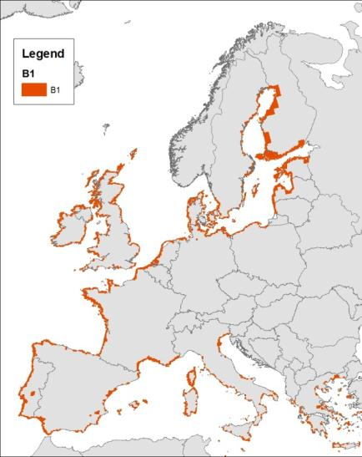 | 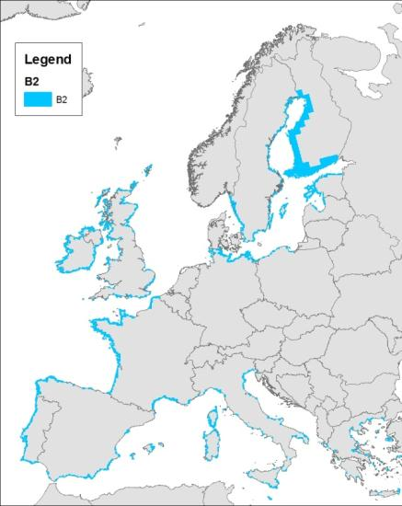
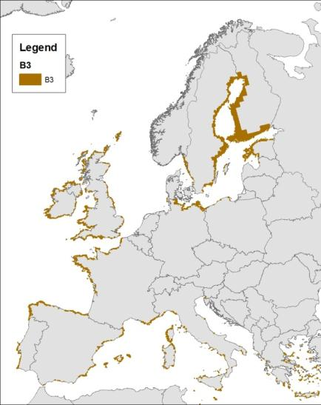

D bogs and mires

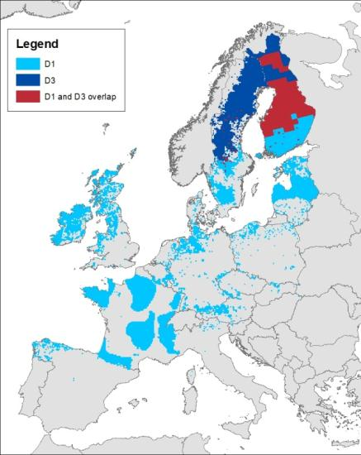
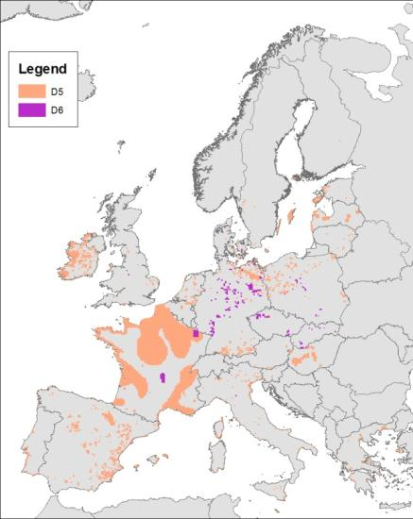

F heathlands
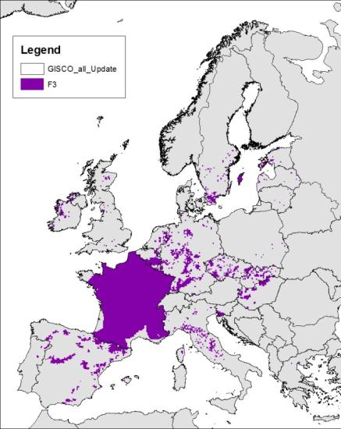 | 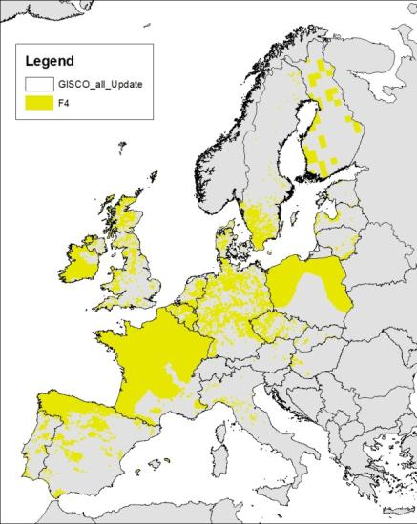

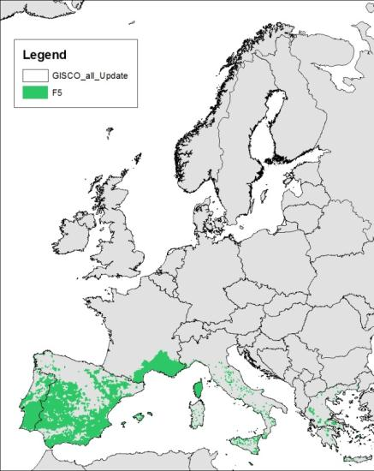 | 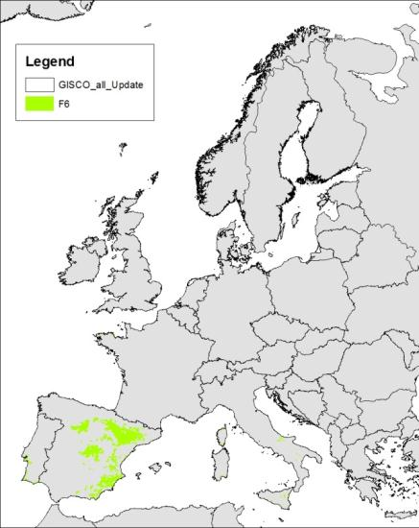
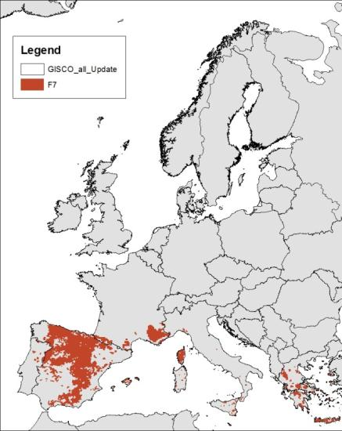

Source: Ad-hoc-Working Group Soil: Bodenkundliche Kartieranleitung, Hrsg.: Bundesanstalt für Geowissenschaften und Rohstoffe in Zusammenarbeit mit den Staatlichen Geologischen Diensten, 5. Aufl., Hannover 2005. ISBN 3-510-95920-5

